**Data Analytics with Cognos**

**Covid vaccine Analysis**

**Dhanalakshmi Srinivasan college of Engineering and Technology**

**INFORMATION OF TECHNOLOGY**

*SubmittedBy,*

NAME: VINAY KUMAR

DEPT: B-TECH (IT)

REG. NO: 310521205063

NAME: PRABHAT KUMAR

DEPT: B-TECH (IT)

REG. NO: 310521205037

**Under the guidance of**

IBM: DAC101

Table of Contents

|  |  |
| --- | --- |
| Abstract………………………………………….. | …………………………………………………...01 |
| Introduction……………………………………. | …………………………………………………..02 |
| Literature Review……………………………. | …………………………………………………..03 |
| Problem Statement………………………….. | …………………………………………………..04 |
| Solution………………………………………….. | …………………………………………………..05 |
| Result and Analysis………………………… | …………………………………………………..06 |
| Conclusion and Discussion……………….. | …………………………………………………..57 |
| Future Scope of Work………………………. | …………………………………………………..58 |
| References…………………………………….... | …………………………………………………..59 |

COVID - 19 ANALYSISANDPREDICTION

## Abstract

COVID-2019 has been recognized as a global threat, and several studies are being conducted in order to contribute to the fight andpreventionofthispandemic.Thiswork presents a scholarly production dataset focused on COVID-19, providing an overview of scientific research activities, making it possible to identify countries, scientists and research groups most active in this task force to combat the coronavirus disease. The dataset is composed of 40,212 records of articles’ metadata collected from Scopus, PubMed,arXivandbioRxivdatabasesfromJanuary2019toNovember2020.Thosedata were extracted by using the techniques of Python Web Scraping and preprocessed with Pandas Data Wrangling. In addition, the pipeline to preprocessandgeneratethedataset are versioned with the Data Version Control tool (DVC) and are thuseasilyreproducible and auditable.

This huge amount of data is used here to create the analysisandpredictionmodelofthe whole system. The prediction model is completely based on the datas given by various universities and organisations (all the links are there right at the end of the project). Based on the huge data we have Predicted the model for India based upon the recovery rate, death rate and the hospital beds present there in each of every state.

Apart from that we have analysed the whole thing and concluded the facts about the Lockdown procedure followed by various countries and provinces. Whether the procedure worked successfully or not based on the datas we have made an analysishere and represented in a decent manner.Hencetheprojectname**Covid-19:Analysisand Prediction** is justified here.

*N.B. Everything is based upon the dataset provided by the open source of the organisations and as per the datasetwehavegotthedatasupto 15th November, 2020. Hence the prediction model may be changed if new and fresh data is given input here.*

# Introduction

On30January2020theWorldHealthOrganization(WHO)declaredthatthe SARS-CoV-2 outbreak constitutes a Public Health Emergency of International Concern (PHEIC). The COVID-19 crisis is putting high pressure on the research community to speed up science discovery, inform the public health response and help save lives, as demonstrated by the activation by the WHO of the R&D Blueprint to accelerate diagnostics, vaccines and therapeutics for this novel virus. A necessary complementary action to accelerate and amplify impact is to ensure that research findings and data relevant to this outbreak, are shared as rapidly, openly and effectively as possible.Therefore, the European Commission urges researchersofHorizon2020grants withresearchoutputsthat-in any way - may be used to advance the research on COVID-19, to provide immediate open access to their related publications, data and any other output possible, in line with the guidance offered in this document. These can be projects specifically researching on the corona virus, but also other research fields/disciplines with relevance to tackle the corona crisis. Similarly, the European Commission urges research infrastructures projects, developing and/orprovidingaccess services to relevant research tools and resources, to provide priority and customised access to their services for research on COVID-19.More particularly, the European Commission strongly encourages beneficiaries to follow the guidelines below, thereby exceeding the current Open Access requirements of Horizon 2020 andgoingbeyondthe legal obligations enshrined in the Horizon 2020 Grant Agreement (GA), in order to address the current public health emergency. The guidelines build on both the commitments made by the European Commission as a signatory of the Statement on Data Sharing in Public Health Emergency, and on the principles established in the GA.

# LiteratureReview

As per the datas providedbytheChineseMediaCDCweeklythenumberofCovid-19cases increased daily in drastic manner in the month of January and March, 2020[1]. They have also created a database where they have stored the datas and analysed the fact of the outbreak. Similarly the government of Hong Kong have created an official website to create awareness against this deadly virus and provided the daily datas for the sake of the people[2].

While theEuropeancountrieshavealsoprovidedthecompletedatabaseaspertheper day stats and cases and theyhavealsopredictedtheirmodelwhichwasquiterealisticunless and until the second wave of the outbreak arrived[8]. To provide insight into the impact of COVID-19 on insurance coverage, CHIA is now producing monthly enrollment data summaries by key market sectors. This new report series is in addition to CHIA's regular biannual Enrollment Trends reports. CHIA intends to continue this reporting on amonthly basis as the impact of COVID-19 is further felt across insurance categories and market sectors.[4]

The Government of India gathered the information and created the database[11] and according to that many sectors like thehospitalfacilitiesandthehealthsectorshaveopened up their loopholes andarereadytodevelopmoreandmore.AmonthagoUniversityofJohn Hopkins provided the prediction model in which they predicted the outbreak in a huge manner and represented the World, which was quite amazing, from that point of view this work is a valuable one[12]. They have also provided the safety measures and also they have studied the whole thing from their point of view.

## ProblemStatement

In this Research Project “Covid-19 : Analysis and Prediction” we haveworkedwithvarious problem statements. They are,

* Wheredidthisvirusoutbreak?
* Howitaffectedthemajorcountriesalongwiththewholeworld
* LOCKDOWN:Whetheritwassaviouror, not?
* INDIA:CurrentsituationandAnalysis
* WhetherthehealthfacilityofIndiaisupagainstCovid-19?
* ThePredictionModel

These are problem statements that we have analysed and discussed in this research project and got the solutions.

## Solution

Aspertheproblemstatementsthatwehavechosen,wehavedevelopedaMachine Learning model and created a data analysis to find out the answers of these questions.

Firstly, we have collected the data from various resources and combined them and cleaned them up for our better uses. After that, we have imported all the necessary packages and libraries to provide the solution that we want.

* Wheredidthevirusoutbreak?WelltheanswerisHubeiprovinceofChina.Asperthe

analysiswehavegotthemostnumbercaseswereseenfromHubeiinbetweenthe period of January and March, 2020

* ThisCovid-19hasaffectedalmost246countriesandamongthemtheUSA,Indiaand

Brazil are the worst candidates. This is also ensured with thehelpofthedataanalysis and graphical representation.

* For some countries it was the saviour, the Lockdown and for some countries it was just a layer of security nothing more thanthat.Everythingisdenotedbythegraphical analysis later in this project paper.
* ToanalyzeaparticularcountrylikeIndia,themainthingsarethemortalityrates,the

recovery rates and the health facilities provided by the country. Based on these facts we have done the analysis.

* Asperthedatawehavetrainedourmodelandtestedthepredictionmodelandhence

providedthefinalpredictionwhichisquiterealistic.

To answer the problem statements we have gone through this procedure to answer all the things quite effectively.

## ResultandAnalysis

**Coronavirus disease 2019** (**COVID-19**) is a contagious [respiratory](https://en.wikipedia.org/wiki/Respiratory_disease) and [vascular](https://en.wikipedia.org/wiki/Vascular_disease)[disease caused](https://en.wikipedia.org/wiki/Disease) by [severe acute respiratory syndrome coronavirus 2](https://en.wikipedia.org/wiki/Severe_acute_respiratory_syndrome_coronavirus_2) (SARS-CoV-2).Thefirst case was identified in [Wuhan](https://en.wikipedia.org/wiki/Wuhan), China in December 2019, though evidence suggests that the virus may have already been actively spreading months earlier in places such as Italy.

Common symptoms of COVID-19 include fever, cough, fatigue, [breathing difficulties](https://en.wikipedia.org/wiki/Breathing_difficulties), and [loss of smell](https://en.wikipedia.org/wiki/Anosmia) and [taste](https://en.wikipedia.org/wiki/Ageusia).Symptoms begin one to fourteen days [after exposure](https://en.wikipedia.org/wiki/Incubation_period) to the [virus](https://en.wikipedia.org/wiki/Virus).While most people have mild symptoms, some people develop [acute respiratorydistress syndrome](https://en.wikipedia.org/wiki/Acute_respiratory_distress_syndrome) (ARDS). ARDS can be precipitated by [cytokine storms](https://en.wikipedia.org/wiki/Cytokine_storm),[multi-organfailure](https://en.wikipedia.org/wiki/Multiple_organ_dysfunction_syndrome),[septicshock](https://en.wikipedia.org/wiki/Septic_shock),and[bloodclots](https://en.wikipedia.org/wiki/Thrombus).Longer-termdamagetoorgans(inparticular,thelungs and heart) has been observed.

#### Chapter1:Wheredidthevirusoutbreak?[1]

On December 29 th Wuhan City government starts to trace cases OnJanuary4thShanghailabdetectscoronavirussimilartoSARS

OnJanuary6thWuhandoctor,13nursesinfectedafteroperatingoninfectedpatient

OnJanuary7thPathogenidentifiedasnovelcoronavirus On January 13 th Incubation period identified as 14 days

OnJanuary17thBaibutingneighbourhoodinWuhanholdsLunarNewYearbanquet

OnJanuary19thPulmonologistNanshanZhongannounceshuman-to-humanspread On January 20 th Annual Spring Festival travel rush begins in Hubei Province

OnJanuary23rdWuhanplacedunderquarantine

OnJanuary23rdAnnouncednewhospitaltobebuiltin10days

OnJanuary26thHundredsofmedicalstaff,equipmentandfoodsenttoWuhan On January 28 th Thousands more medical workers sent to Wuhan (1/28-1/29)

OnFebruary1stMemberofChineseAcademyofScienceleadsteamtosupportWuhan

OnFebruary2ndChinaCentralBankcarriedoutareverserepurchaseof1.2trillionRMB ($170B)

OnFebruary3rdFirstWuhanfieldhospitalopens;Morehospitalsbuiltovernight

OnFebruary5thDiagnosticcriteriaexpanded

OnFebruary9thAnother3,187medicalworkerssenttoHubeiProvince

OnFebruary10th19provincespartnerwith16citiesinHubeiforassistance On February 12 th Hubei Province incorporates diagnostic change

OnFebruary14thWuhanasksrecoveredpatientstodonateplasma

OnFebruary19thAnother1,299medicalworkerssenttoWuhanascitydisinfectssewage On February 24 th China bans trade, consumption of wild animals, and postpones annual parliamentary meeting

OnFebruary26thDailynewcasesoutsideChinasurpassthoseinsidethecountry OnFebruary29thChina-WHOjointinvestigationreportonCOVID-19published On April 15 th China issued revised death and case count

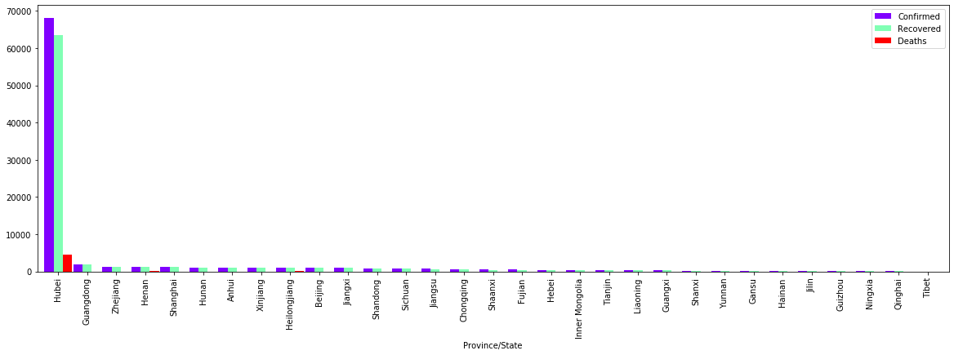

The above representation is showing that the most affected are or, Province in China is Hubei where the confirmed cases are reached to70000andapproximately90%ofthecases of Total China's Confirmed Cases

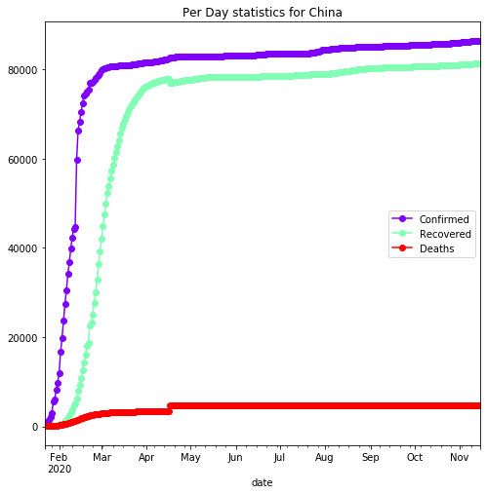

From the confirmed cases plot for China wecanseethatthenumberofnewcaseshavebeen declining with a few constant number of cases everyday.17th April shows a sudden increase in the number of confirmed cases. China is again seeing some increase in the number of cases since 13th June[1]

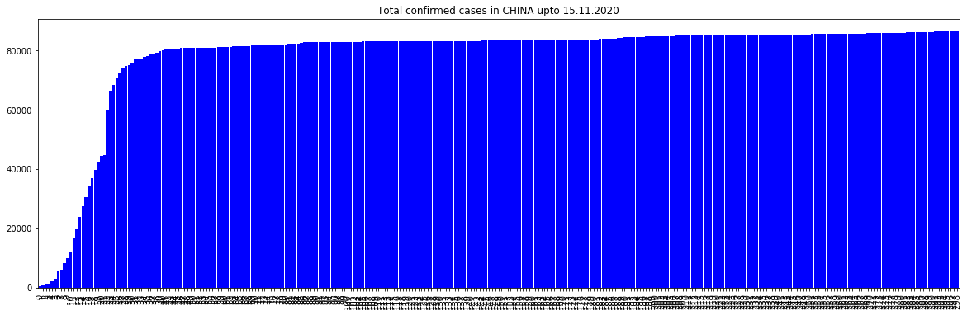AnalysisoftheconditionofChinaduringtheoutbreak:

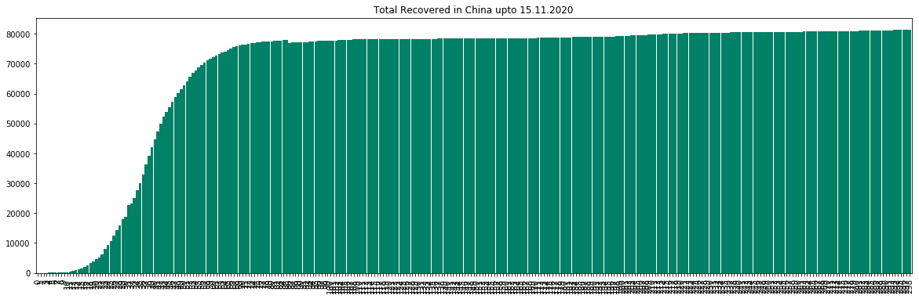

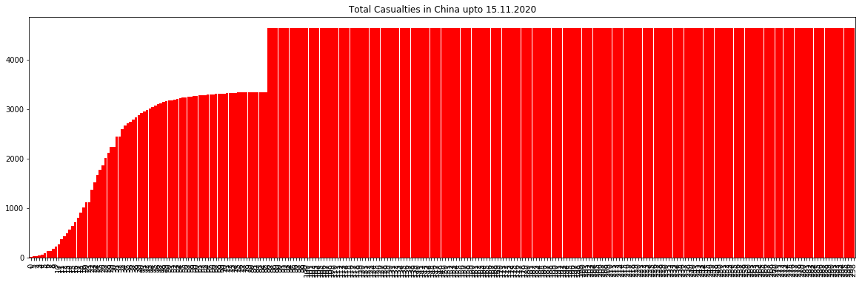

Understanding from the graph :TheTotalno.ofConfirmedcasesinChinagraphshowsthat the graph is flattened after May, 2020, which shows that the increment in the cases is not exponentially in the recent times as the graph is Flattened

ConfirmedandDeathcasesincreaseinChina:

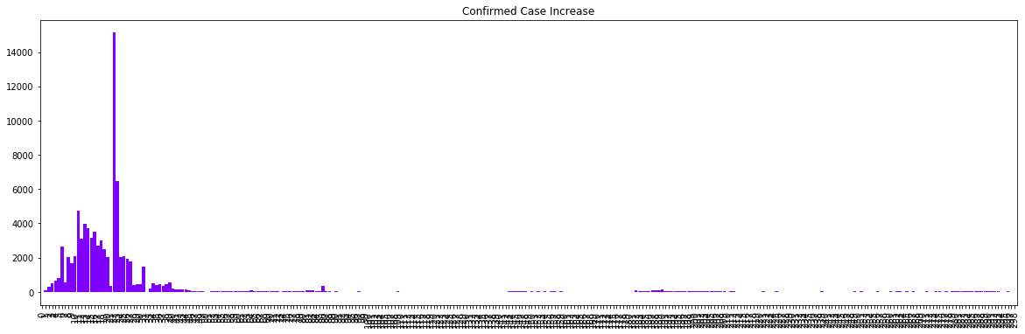

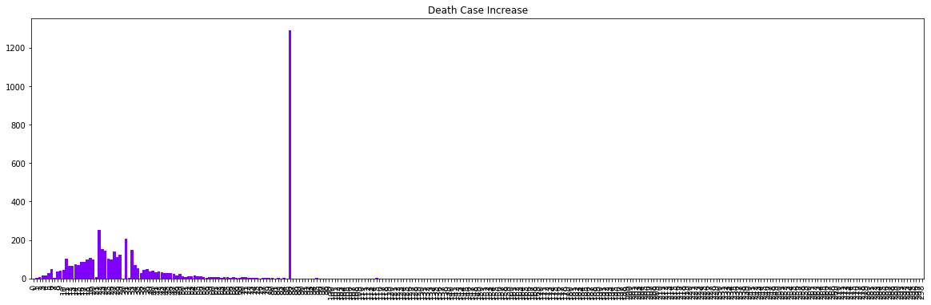

From the Death Increase plot for China we can see that deaths havereducedtoagreatlevel but on 17th April there were 1290 deaths reported in a single day. China reported this increase as some miscalculation on their end during the initial phase of COVID.

#### TheHotspot:HubeiProvince

Wuhan was placed under a strict lockdown that lasted 76 days. Public transport was suspended. Soon afterwards, similar measures were implemented in every city in Hubei province.Acrossthecountry, 14 000 health checkpoints were established at public transport hubs. School reopenings after the winter vacation were delayed and population movements were severely curtailed. Dozens of cities implemented family outdoor restrictions, which typically meant that only one member of each household was permitted to leave the home every couple of days to collect necessary supplies. Within weeks, China had managed to test 9 million people for SARS-CoV-2 in Wuhan. It set up an effective national system of contact tracing.[1]

We plot the perdaystatisticsforHubeisinceithasthehighestrateofconfirmedcases in China If we compare the China and Hubei plots, they both are similar. Hence wecansay that the China stats are influenced deeply by a single province

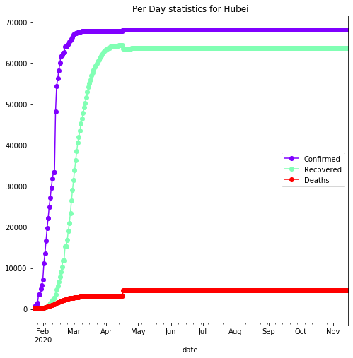

While talking about China the main root of the epidemic is Hubei Province where the confirmed cases were increased from 10000 to 70000 in a gap of just 25 days inthemonth of February and March, 2020. The root of the epidemic is hereby **HUBEI province of China.[1]**

### Chapter 2 : Spread Out of the Virus

The 2019 novel coronavirus (2019-nCoV), officially named asCOVID-19pandemicby the WHO, has spread to more than 180 countries including China. Confirmed novel coronavirus cases increased ten-fold in less than a month, from100,000inthefirstweekof March to more than one million on 02 April, while more than 52,000 deaths have been reported across the world.

PerDayStatisticsofWorld:

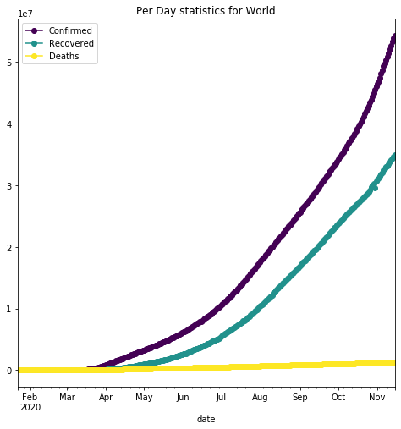

Here the per day statistics tells us thespreadingisexponentiallyincreasingdaybydaysince the end of the March, 2020. Now after 5 months the situation is worse than the previous days and still the cases are increasing exponentially without any kind of stoppings in the increment of the cases.[12]

WorldAnalysisthroughgraphicalrepresentation

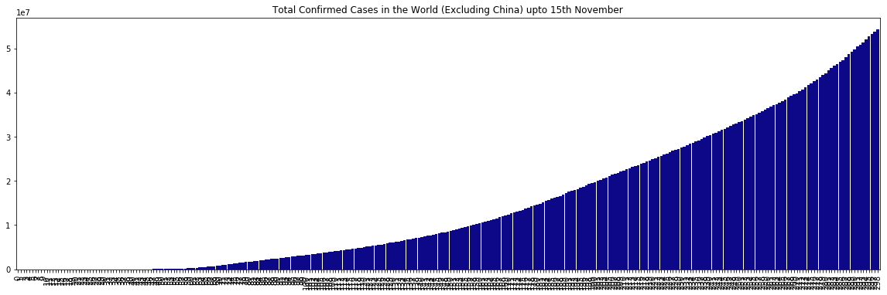

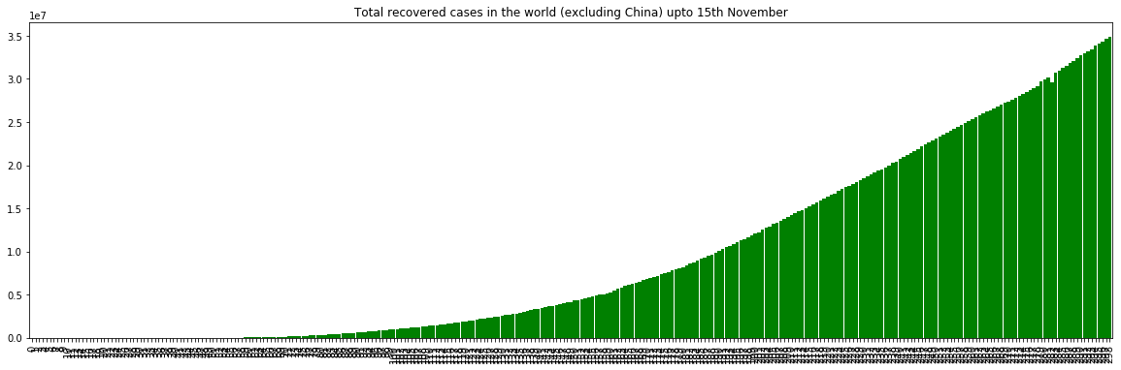

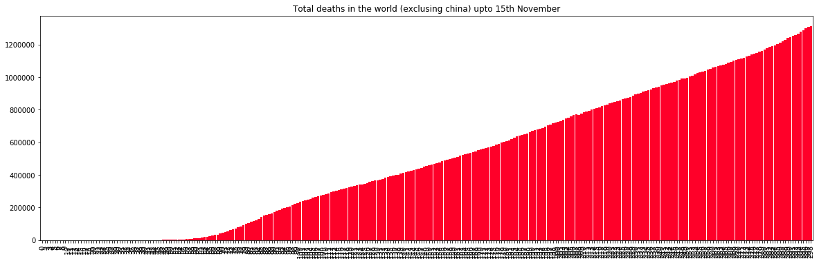

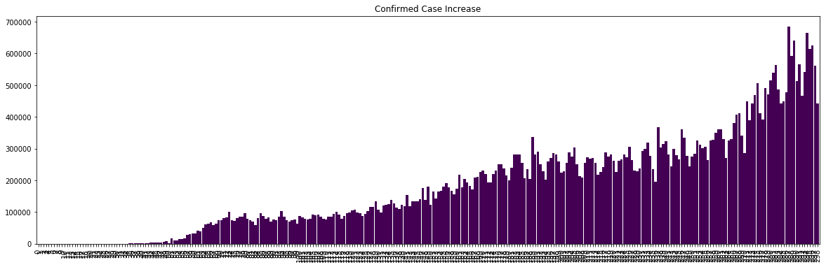

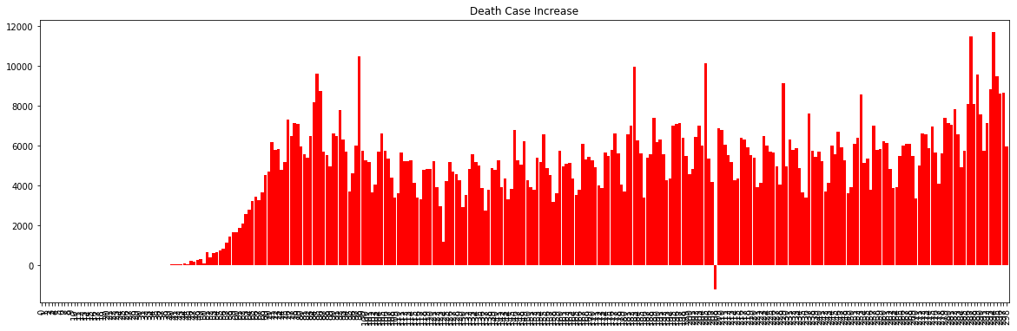

Here on 15th November 2020 the number of confirmed cases has risen to54283840, which is huge in numbers and almost 57% of the total population of the world. In those confirmed cases the Death toll rises to 1312505 and still it is increasing day by day.

Global confirmed cases have been on an increasing trend and this has been largely contributed by Brazil and US at this moment as can be seen in the pie-chart. 29th July saw the highest increase in confirmed cases with 3.37L cases in a day.

Approximately 21% of the total confirmed cases of theworldisfoundatUnitedStates of America.

After USA, there are India and Brazil;, the 2nd and 3rd mostaffectedcountriesinthe world where the percentage of confirmed cases reported with respect totheworldis16.27% and 10.78% respectively.

AffectedCountriescount:246

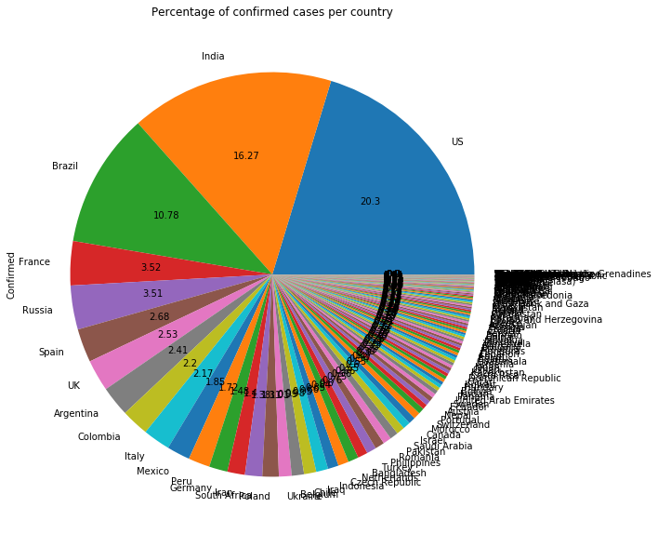

The United States tops the 8.7 million coronavirus case. The United States on Tuesday surpassed 8,704,606 novel coronavirus cases, according to Johns Hopkins University. The pandemichasnow claimed the lives of at least 225,735 people in the United States, which leads the world in thenumber of confirmed infections.[12]

India is now thesecondworst-affectedcountrybyCOVID-19.India'snovelCoronavirustallycrossed the 7.9 million mark on Tuesday with detection of less than 40,000 new cases in the last 24hours, the Indian Health Ministrysaid.ThestateofMaharashtra,AndhraPradesh,TamilNadu,Karnataka and Uttar Pradesh were among the five worst-affected states in India.

Brazil with more than 5.4 million cases. Third, in the list of the worst affected countries, Brazilhas more than 5.4 million confirmed cases, according to Johns Hopkins University. The countryhasso far reported 5,409,854 total cases and 157,397 deaths due to coronavirus.[12]

Russia with more than 1.5 million cases. Russia reported more than 1,537,142 cases of coronavirus infections so farand26,409deaths.Thecountryhasthefourth-highestnumberofinfectionsbehind theUnitedStates,IndiaandBrazil,butthenumberofnewcaseshasseen a stellar rise every day in

the past month.

Francewith1.2millioncoronaviruscases.France'snovelcoronavirustallycrossed the 1.2 million mark on Tuesday with the death toll rising to 35,052, according to John Hopkins University.

Top 5 countries with Confirmed cases, Death cases and Recovered cases :

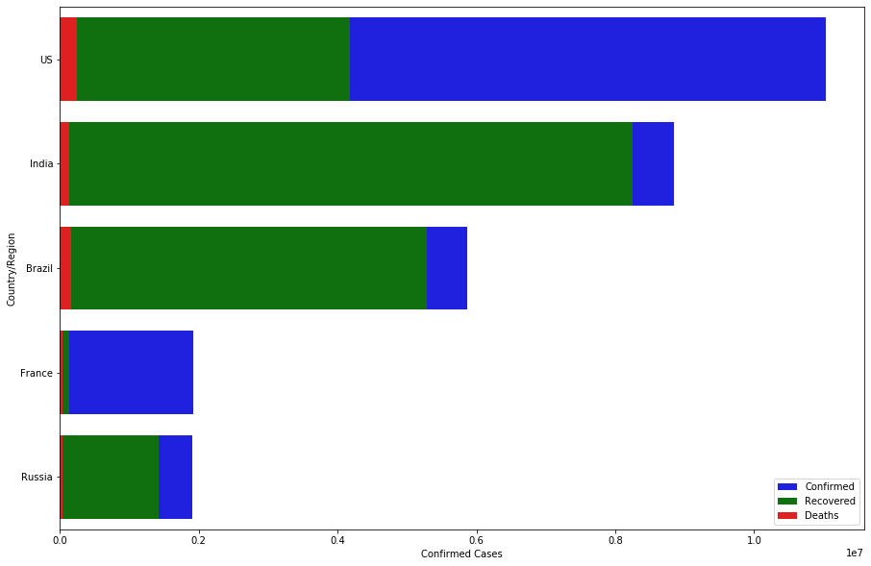

#### ITALY:TheSecondEpicenter

First outbreak: Italy was first affected with COVID 19 on 30 January, when two positive cases were reported in Chinese tourists. Italy COVID cases reached 59,138 on 23 March, marking the biggest coronavirus outbreak outside Asia. And Italy was announced as the second most affected coronavirus country in the world with the cases increasing at ahigher rate than any other country. Total affected: If we see the graph of the affected rate, we can understand the cases were approximately the same upto August 25. After that it has been increasing and currently it has 1455022 positive cases by now(Till 24 november, 2020). Death rate: The death rate was suddenly increased in the mid of March and it was approximately at an equal level till October 20. After that it has been increasing like the affected rate till now. The daily death cases were toohighfromlastweekofFebruarytomid of April.[10]

Italy was the second epicentre for COVID19,hence let'slookatthesenumbers.Thenumbers are high and confirmed cases are increasing by the day. However the increase rate for confirmed cases has been constant and may soon be seeing a plateau phase. Recovery and deaths were both neck to neck with some divergence over the last few days.Italy has more than 1L confirmed cases on 30th March

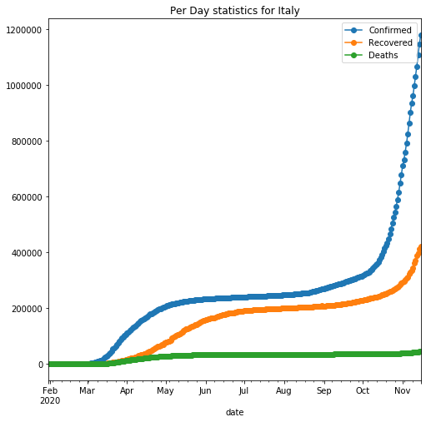

AnalysisofItaly:

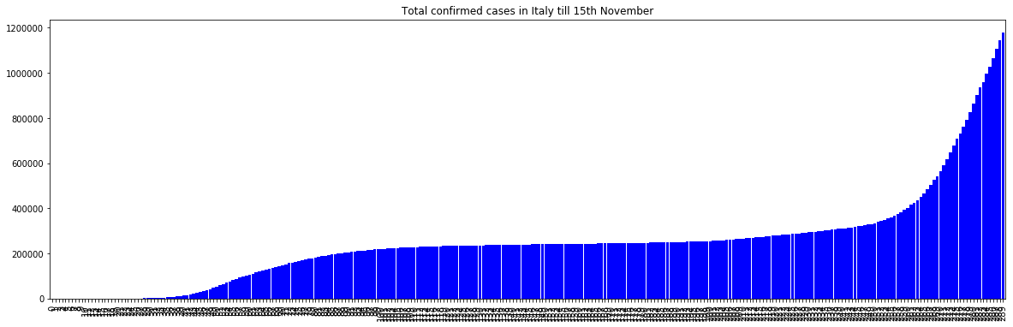

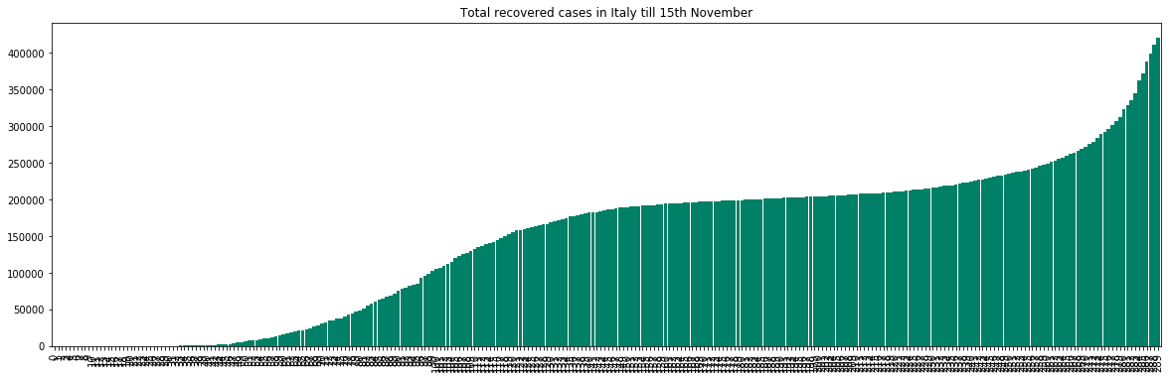

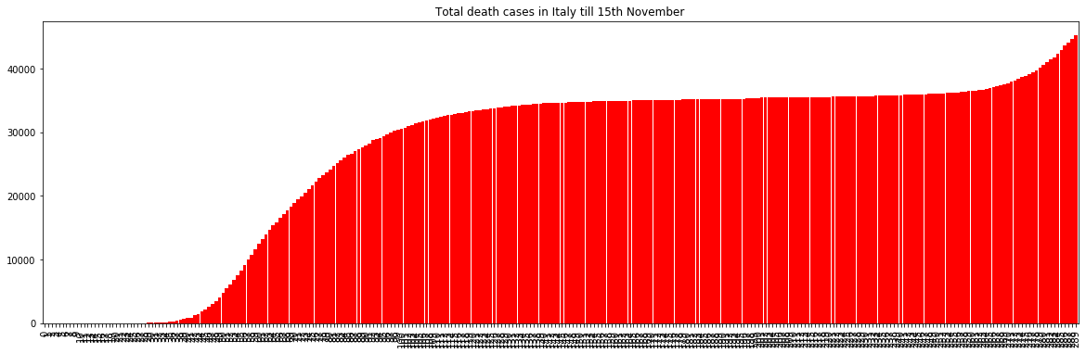

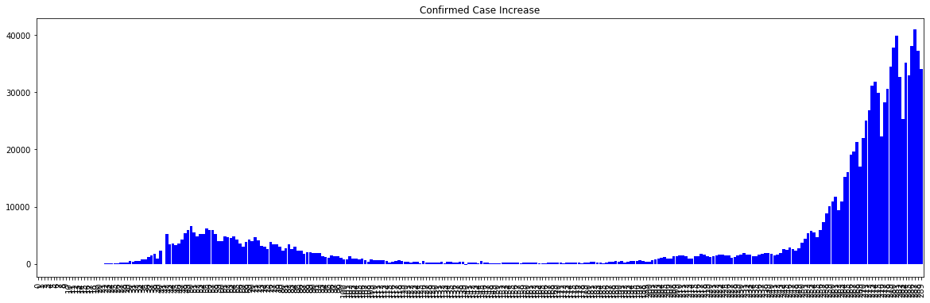

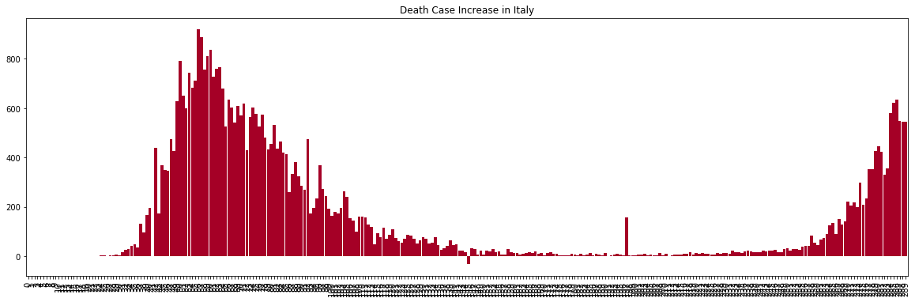

These are the trends and the analysis of the data. As you can clearly see that the daily increase in the death cases and confirmed cases increased second time due to the second wave of the virus.

### United States of America : The 3rd Epicenter

First outbreak: Covid was first identified in the USA in December 2019. The World Health Organization declared the outbreak a Public Health Emergency of International Concern in January 2020 and a pandemic in March 2020.

Total affected: Positive cases till November 25 is 12276834. Cases are respectively higherin October than the last few months. Rate of confirmed cases is daily changing.

Death rate: Total number of deaths 255850. On November 21, the number of deaths was 2036; in 25 it was 1052. Death rate is decreasing and it is less thanthenumberofdeathsin March to mid May.[5]

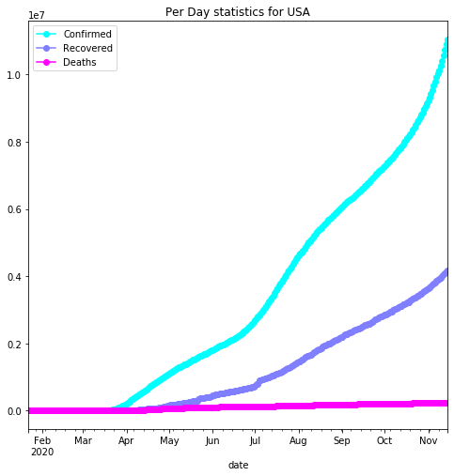

On 16th July the confirmed case increase reached a peak of 78k in a day. Every 7 days we notice a peak in the numbers previously however the peak nowadays occurs in 4-5 days.

AnalysisofUSAbasedontheconfirmedcases,deathcases,recoveredcases:

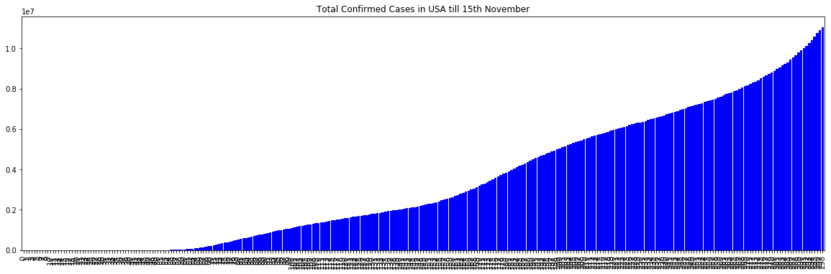

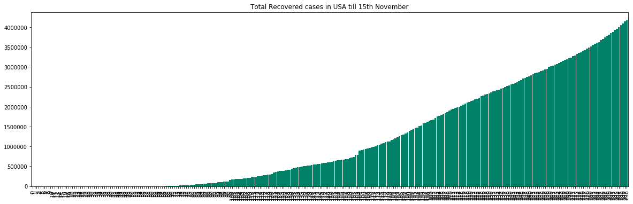

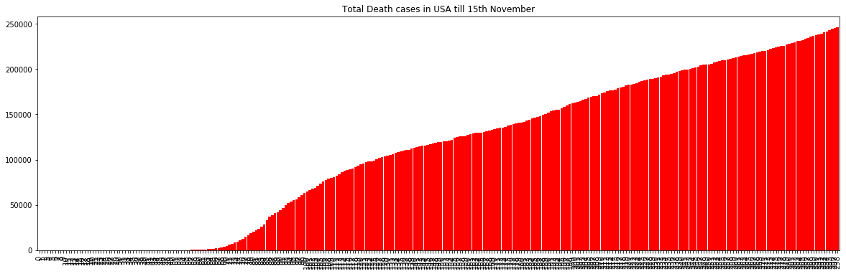

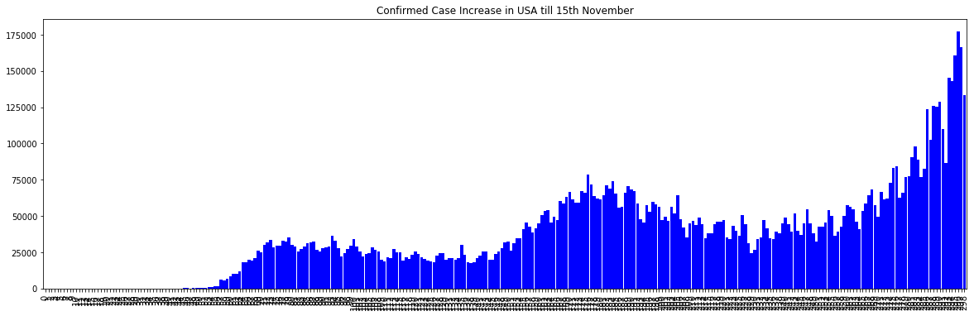

In the mid of June the confirmed casesaredecreasedandtheincrementationisflattenedby a certain moment. But unfortunately in the last week July the incrementation in the confirmed cases are increased suddenly with asteepslope.Afteraweekofsteepslopeinthe increment of the confirmedcasesthereisadecrementintheconfirmedcasesinadailybasis manner.Aswecanseeinthegraph,thatafteraweekofhighrisethepeaksarecominglower and lower day by day. Which shows that the confirmed cases and decrementing day by day slowly. It's really a big sign of improvement for United States

Similar increase has been seen in the deaths reported by US with highest number of deaths(4591) recorded on 16th April[5].

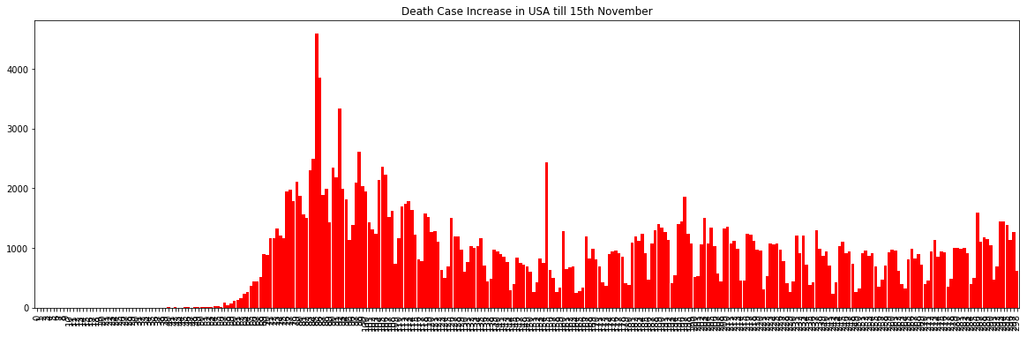

As the graph shows that on the particulardayof16thApril2020USAreportedahighestno. of death cases. After that the death cases are slowly coming down to a certain limit but suddenly in the recent times the Death cases are increasing day by day which is very much annoying for USA

### South Korea : The Role-model

First outbreak: First confirmed case was founded in south korea on 20 January 2020. The number of confirmed cases increased after 10 February.

Total affected: In the present situation the total cases is 31735.Cases are increasing after February in a linear scale. Daily number of new cases was too high in February then it was reduced, after August 16 to September mid it was extremely high.

Death rate: Number of death cases are increasing from February but daily death was in the top level in mid of March. Total number of death is 513 till November 25, and recovery number is 26825

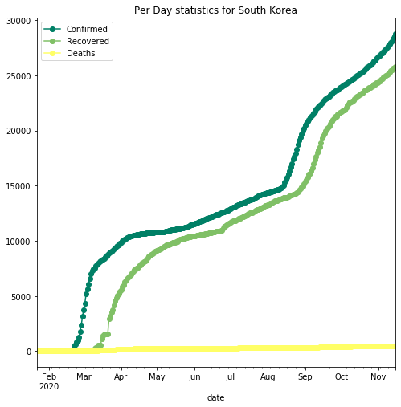

In the recent times if we check out the no. of Confirmed case Increase, we can find that the cases are barely minor as compared to the whole world. And the Death Case Increment is now down to 0 in the recent times. Which shows that SOUTH KOREA is able to fought against the virus with minimum casualties of 494 till 15th November, 2020.[12]

AnalysisofSouthKoreabasedontheconfirmedcases,deathcases,recoveredcases:

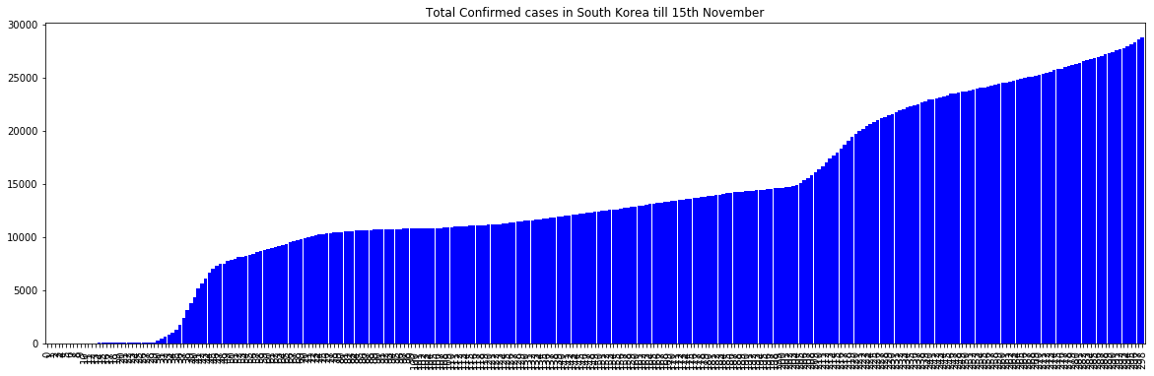

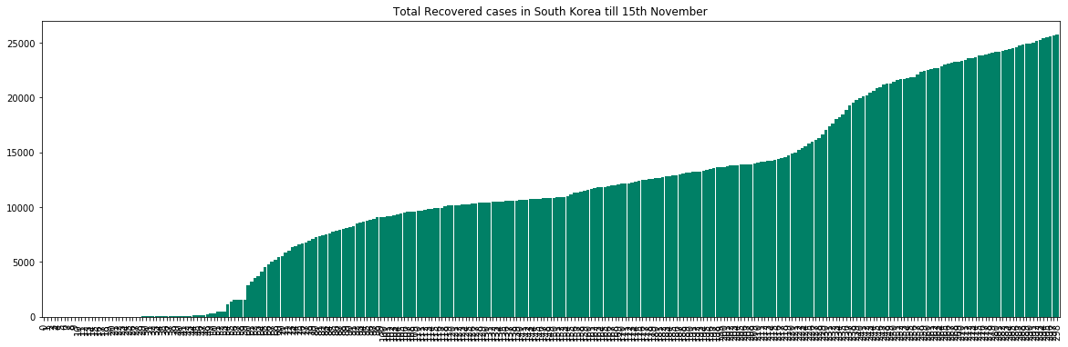

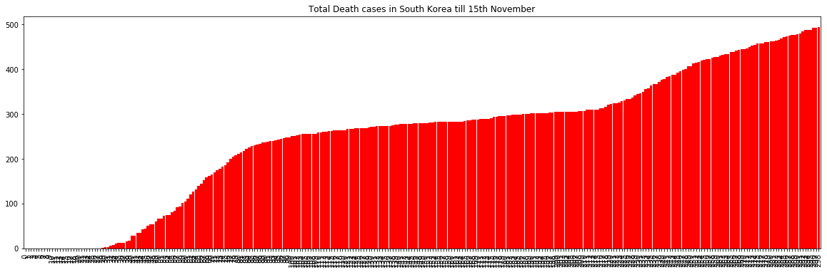

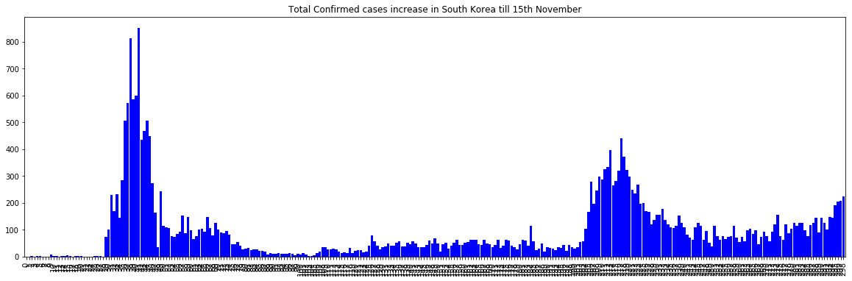

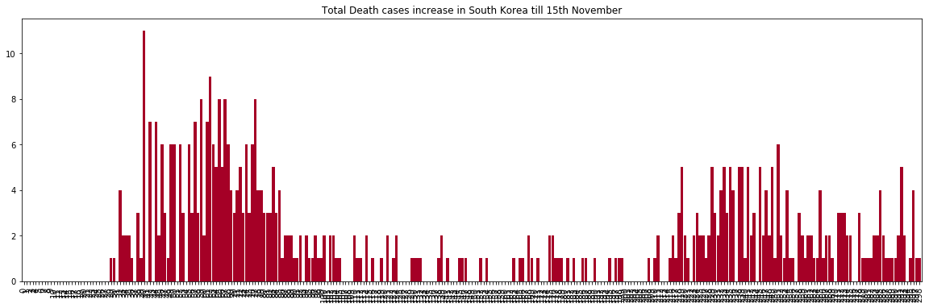

Aswecanseethat the confirm cases are lowered to merely 100 per day which signifies the great work of South Korea to fought against the virus

AlsotheDeathCasesareloweredto2to4andfromtherecentfewdaysitturnsouttobe0

### United Kingdom : Analysis

Firstoutbreak:ThevirusreachedthecountryinlateJanuary2020.Theworld's eighth-highest death rateperhundredthousandpopulationsandthehighestnumberoverall in Europe.

Total affected: As of 2 November 2020 there have been 1,256,725 confirmed cases.Number of cases is highly increasing after September 6(2020). Number of daily affected cases is much higher than mid july-August.

Death rate: After March death rate was suddenly increased. Total death toll is 56533 till 25 November. On November 21 new death was 341 in 22 it was 398.Onlyon25Novemberthe number of deaths was 696.[8]

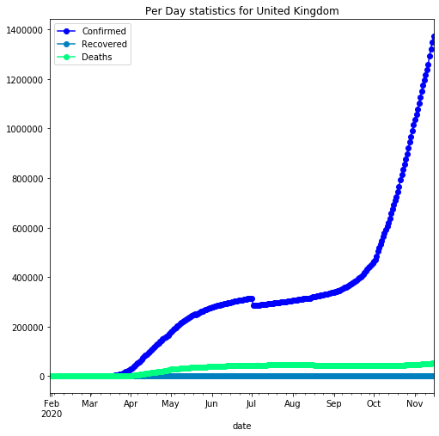

AnalysisofUnitedKingdombasedontheconfirmedcases,deathcases,recoveredcases:

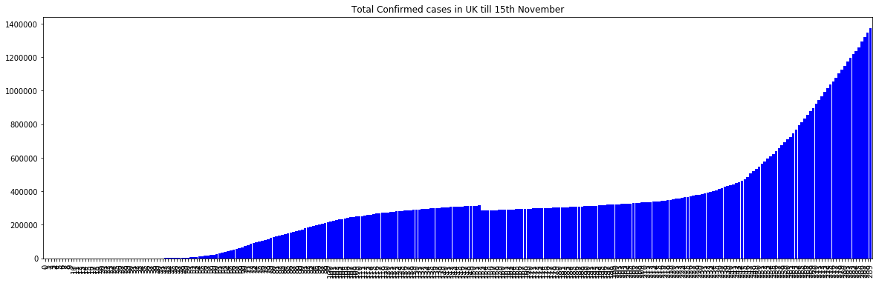

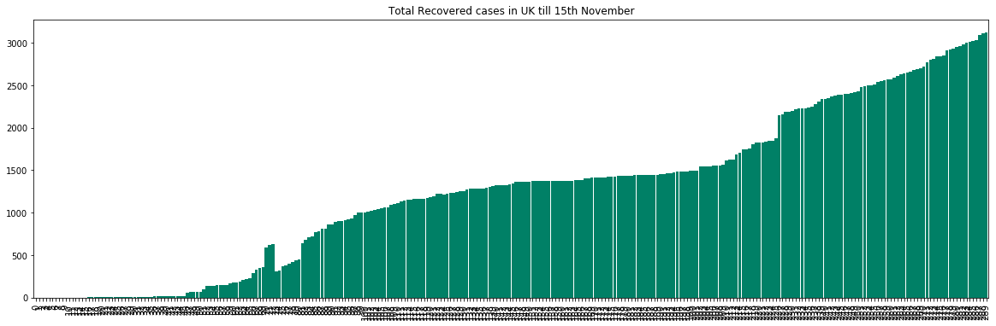

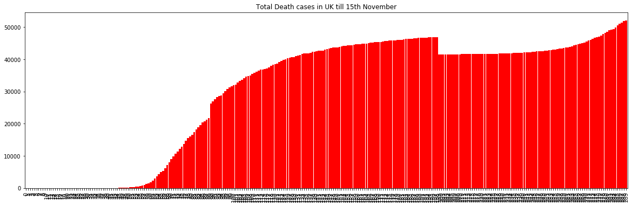

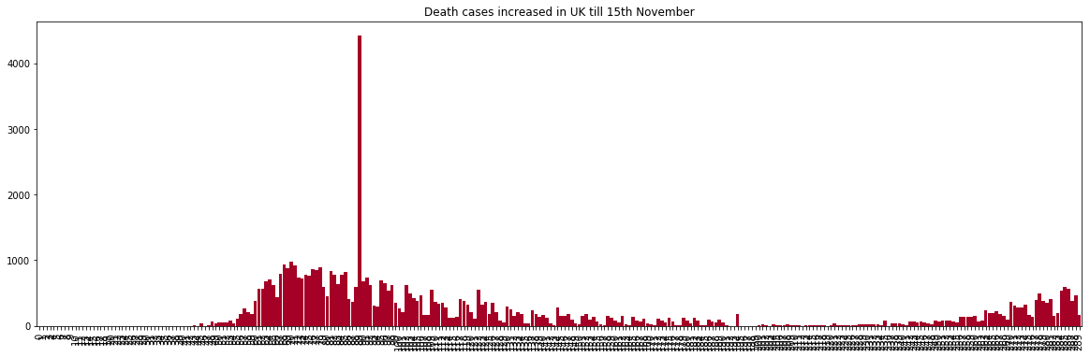

From the Plottings we can clearly observe that the confirmed, recovered and death tolls are flattened pretty much. Which signifies that UK is pretty much controlled the situation

From the analysis we can observe that after the certain stage of the pandemic situation the number of confirmed cases are decreased and level up at a certain range. Intherecentdays the cases are reported near about 100[8]

From the above observation we can also find out that the death cases are not reported in a huge manner in the recent times. The reported death cases are like under 10 per day, some days it is being reported as 0. From the above analysis it is clearly visible to us that the United Kingdom is fought against the pandemic situation quite brilliantly!

Conclusion:UnitedKingdomhasfoughtwellagainsttheCovid-19!

### Germany : Did they do well?

First outbreak: On 27 January 2020, the first case inGermanywasconfirmednearMunich, Bavaria.BymidFebruary,thearisingclusterofcaseshadbeenfullycontained.On25and

26 February, multiple cases related to the Italian outbreak were detected in

Baden-Württemberg.

Total affected: Total positive cases are 983731 till now. Daily number of new cases is highly increasing after September 26.

Deathrate:DeathrateisveryhighafterApril3.Totaldeathtill25Novemberis15381.Butin Germany recovery rate is also high, till now total recovered number is 656400.[8]

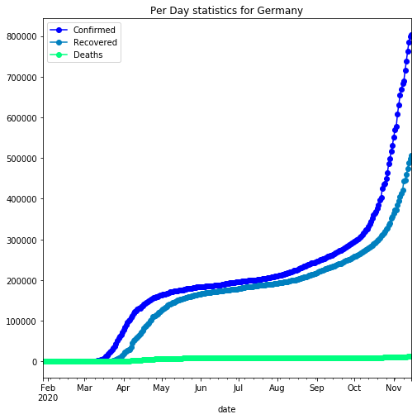

AnalysisofGermanybasedontheconfirmedcases,deathcases,recoveredcases:

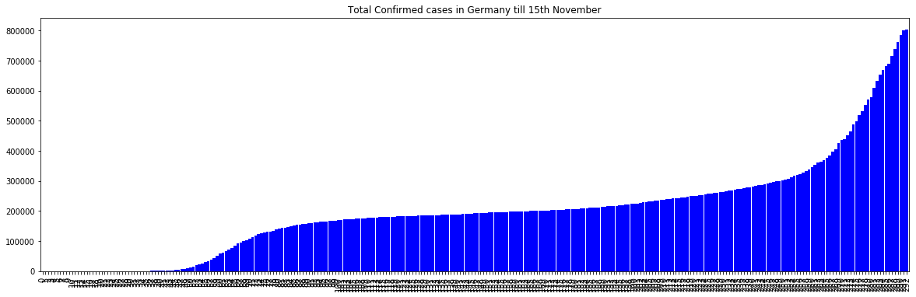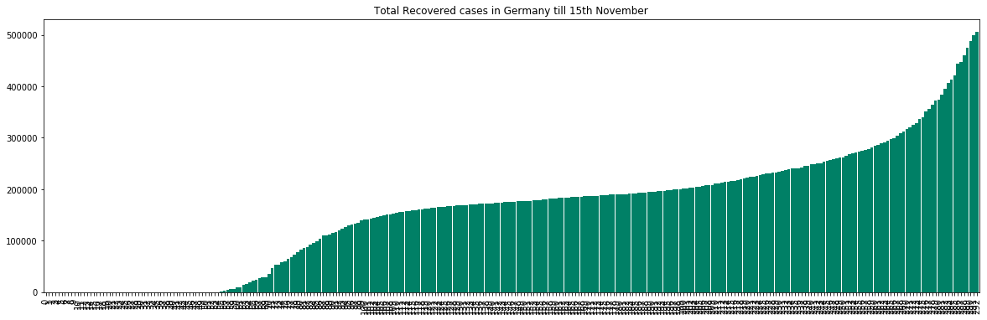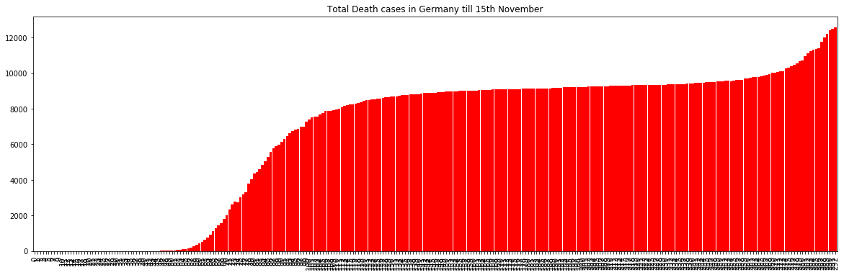

From the graphical analysis of the Total Confirmed cases, Recovered cases and death cases we have seen that the graph is flattened after the peak occured. Which shows that the country is doing quite great job to fight against the virus

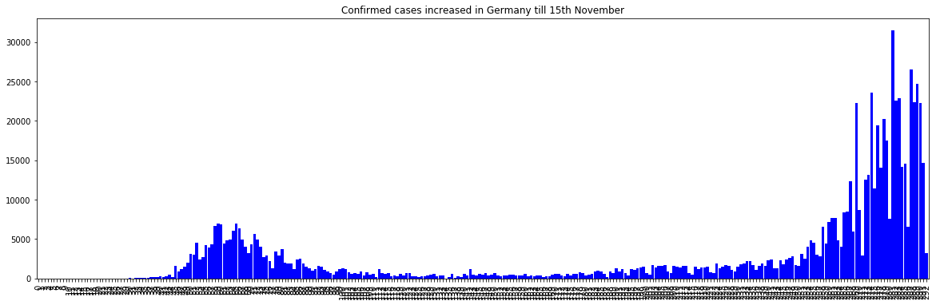

From the graph analysis we have got that the confirmed cases are now lowered to 1000 whereas the peak was at the 7000markafewmonthsback.Whichseemsthatthecountryis healing! But in the recenttimesunfortunatelytheconditionisgettingworserforthecountry as it saw per day 30000 rise suddenly.[8]

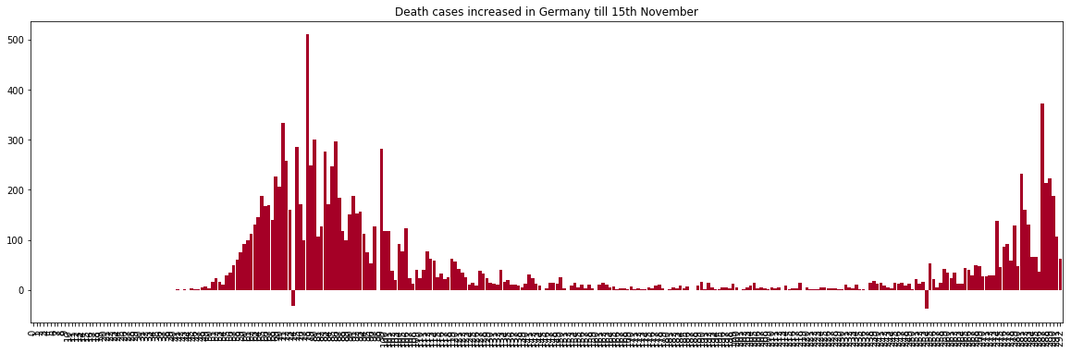

As per theanalysistheDeathtollsdecreasedtominimalnumbersanditisclearlyshowsthat Germany has fought against the virus pretty much

FromtheanalysiswecansaythatGermanyhasovercomethepandemicsituationpositively!

### Tech Country Japan Against Coid-19

First outbreak: On 15 January 2020, the Ministry of Health, Labour and Welfare, Japan (MHLW)reportedanimported case of laboratory-confirmed 2019-novel coronavirus (2019-nCoV) from Wuhan, Hubei Province, China. Total affected: Cases increasing rate is very high from February 15. Totalaffectedis31735.Numberofdailynewcasesislesserthan number of cases in mid February but it was in level from September 12 to November 7. Death Rate: Number of death rate is creasing but daily death cases are reduced from February-March time. Number of death is 2001 till 25 November.[4]

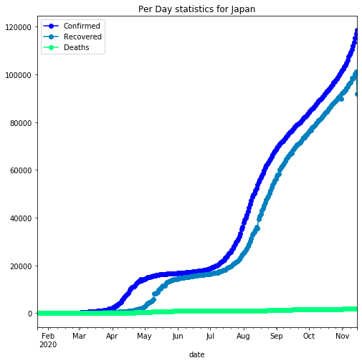

As per the graphical analysis of the data we can observe that the confirmed cases are flattened at the 20000 mark and at that periodweallthoughtthatJapanhasfoughtagainst the virus very well. But unfortunately in the last 2 weeks there is suddenly an upswingwith steep slope upwards has been shown in the curve.ThiscostJapananincrementintheTotal no. of Confirmed casesfrommerely20000toarapid50000injusttwoweeks.Butthemain partof the tension is the new slope in the curve is very much steep and it's upswinging day by day. It does not provide any kind of flatness in the curve which may cost Japan atavery high risk

AnalysisofJapanbasedontheconfirmedcases,deathcases,recoveredcases:

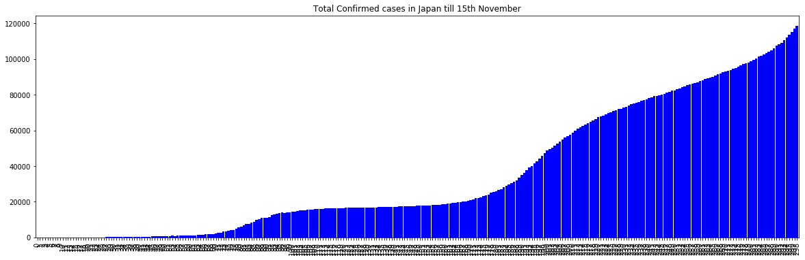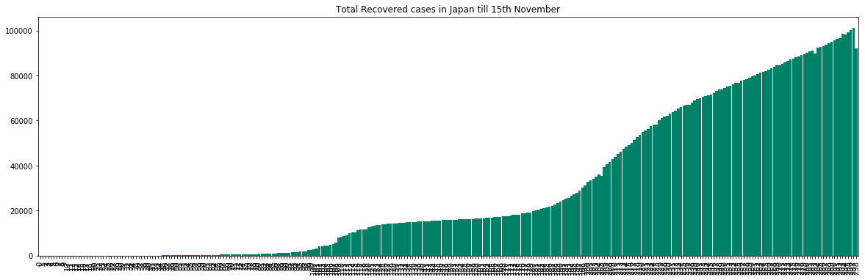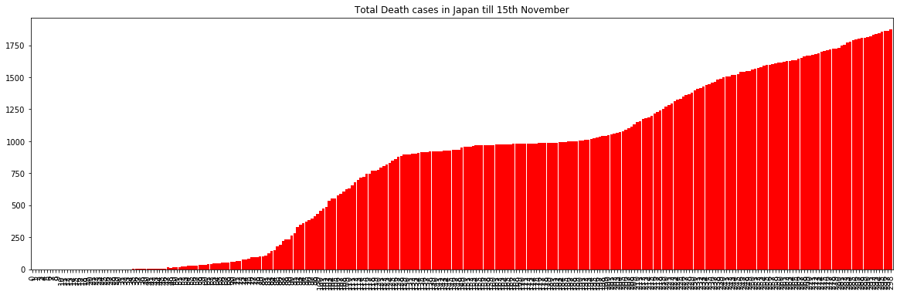

As per the curve of the Total confirmed cases and total recovered cases we can easily said that,Japanmade a huge impact in the in earlier days as a result they saw a flattened curve for 1-2 months. But whwnever they thought that this could end the spread of the virus and re-opened everything, at the very moment thay have seen the upswinging curve suddenly. But a blessing for Japan is that they have controlled the Death cases, as we can see in the curve that it is flattened from last 3 months and there is no sudden increment in the curve. WhichshowsagoodsignfortheJapanGovernment.ButstillJapanhavetobecautious

about the upswinging curve of the confirmed cases though the Death toll is under control right now.[4]

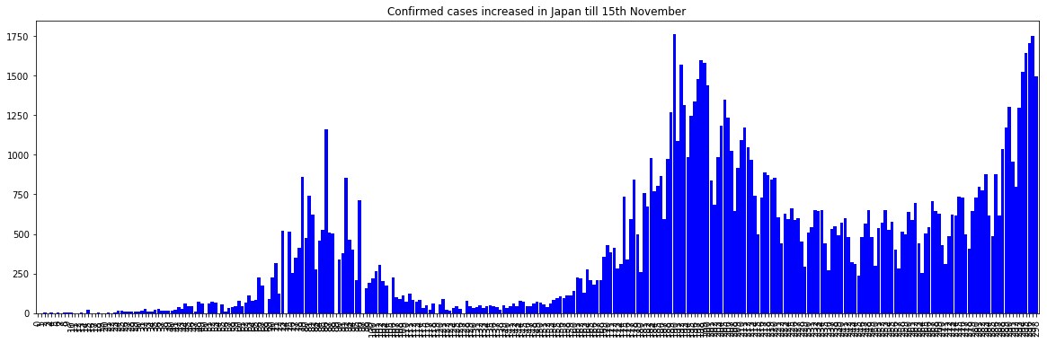

As you can clearly observe that thepeaksarecomingintherecenttimesthoughtheyarenot coming in between of the two peaks in a gap of 2 - 3 months. In the month of May, Japan have shown a massive increment day to day confirmed cases and after that they have managed to bring the manhattans down. but unfortunately the day to day confirmed cases areincreasinginadrasticmannerfromthepreviousone.Theupswingismuchmoresteeper than the previous manhattans. Which may cost Japan!

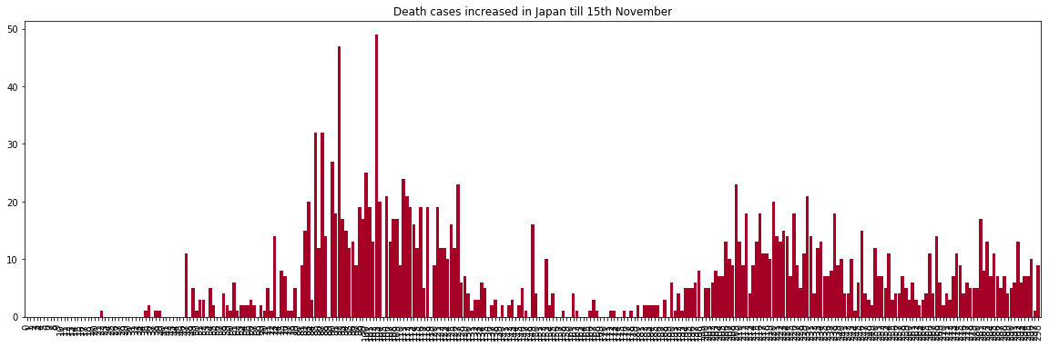

But it is really strange that in the recent timesthedaytodayconfirmedcasesareincreasing in an exponential manner but the death toll is flattened in the past 3 months. Whichshows the dedications of the doctors and the management of Japan Government to prevent the death toll in this high time of spreading. Which is a great news and achievement for Japan

In the last 2-3 months Japan have flattened the curve of the confirmed cases, but unfortunately whenever they are all set to re-open everything at that very moment the confirmed cases are increasingdrasticallyandhigherthanthepreviousupswings.Japanhas controlled the situation but right now suddnly they are also facing the huge upswings andthe steep slopes in the curve, though they have prevent the death tolls in the recent high time.[4]

Australia:Analysis

The first confirmed case in Australia was identified on25January2020,inVictoria,whena man who had returned from Wuhan, China, tested positive forthevirus.Australianborders were closed to all non-residents on 20 March. Social distancing rules were imposed on 21 March, and state governments started to close 'non-essential' services.The number of new cases initially grew sharply, then levelled out at about 350 per day around 22 March, and started falling at the beginning ofApriltounder20casesperdaybytheendofthemonth.A second wave ofinfectionsemergedinVictoriaduringMayandJune,whichwasattributedto an outbreak at a Melbourne hotel used for quarantining international arrivals. The second wave was much more widespread and deadlier than the first; at its peak, the state had over 7,000 active cases. The waveendedwithzeronewcasesbeingrecordedon26October,Asof 25 November 2020, Australia has reported 27,854 cases,25,355recoveries,and907deaths, with Victoriaaccountingfornearly75percentofcasesand90percentoffatalities.Compared to other Western countries, notably the United States and European countries, Australia's handling has been praised for its effectiveness and fast-forward reactions.[7]

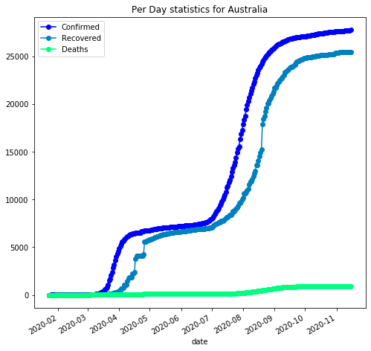

AnalysisofJapanbasedontheconfirmedcases,deathcases,recoveredcases:

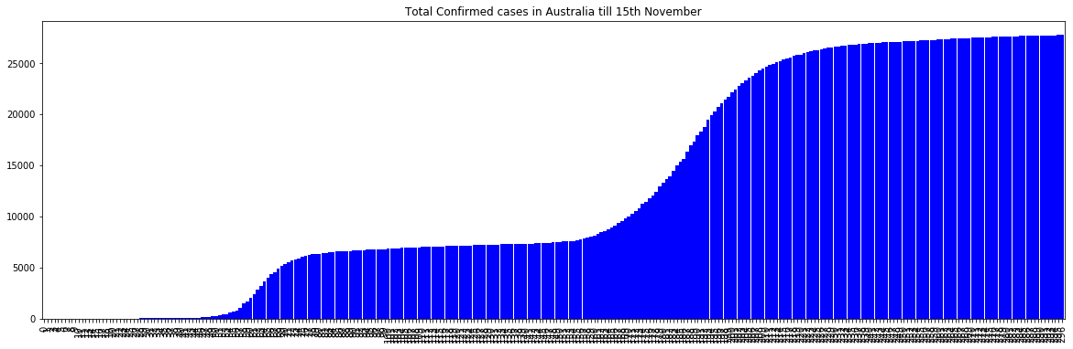

As we can see that the flattened curve is upswinging nowadays, which may cause some serious issues for the country in the recent times. The upswinging curve of total confirmed cases show that the no. of confirmed cases are increased in the recent times and it's happening suddenly like Japan is facing

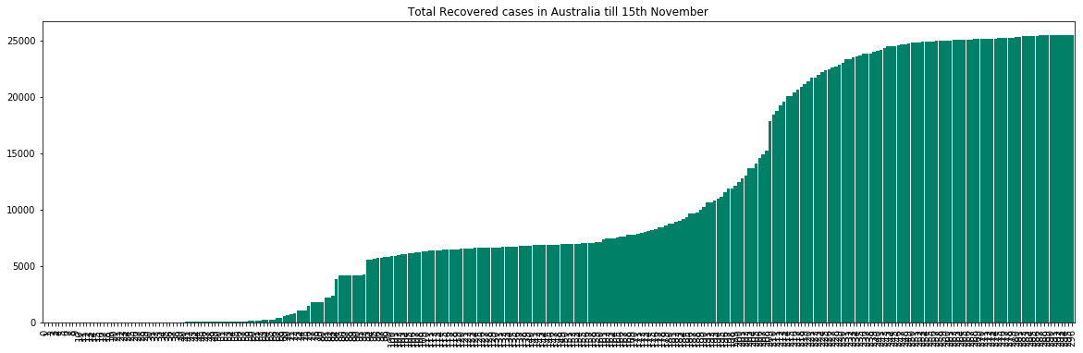

As wecanobservethatthecurveoftheconfirmedcasesareincreasingdaybydayandbeside that the recovered cases are also increasing which shows a pretty positive sign for the country

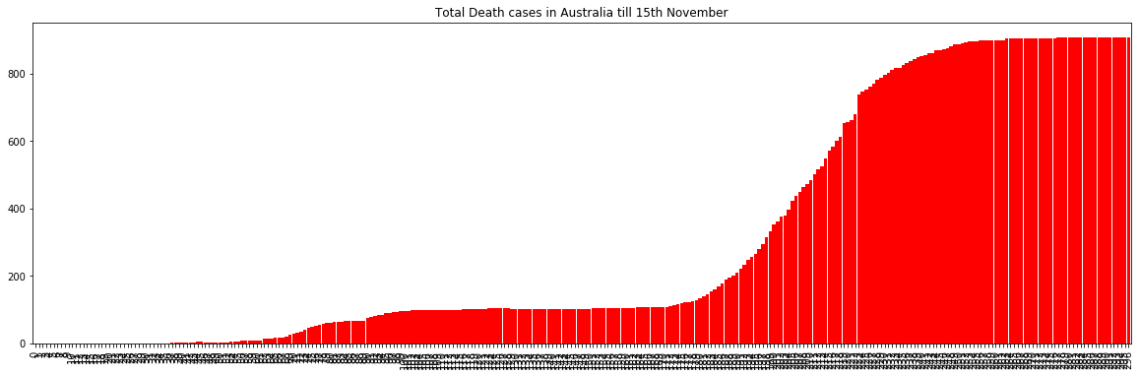

The Death toll is also increasingwiththeincrementofthetotalconfirmedcases.Whichmay cost the country after a certain relaxation period of flattened curve.

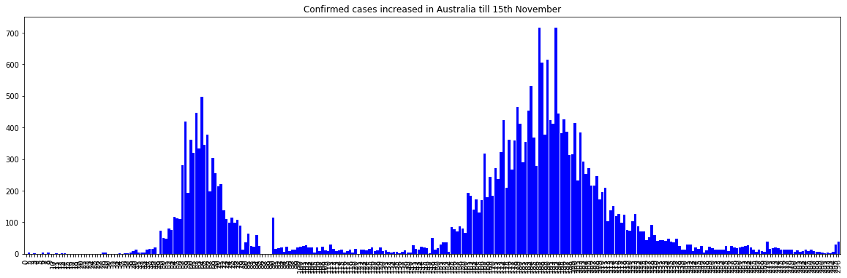

As theconfirmedcasesareincreasingdaybydayinahugemanneritisverydifficulttoshow composure for the Government of Australia. The confirmed cases were came down to 50 in the past 2-3 months after the drastic situation. But unfortunately it's growing higher thanthe previous manhattans and showing a peak of 700 per day. But the good thing is that, in the recent times the confirmed cases per day are come down to 400 mark, which shows a good sign for Australia[7]

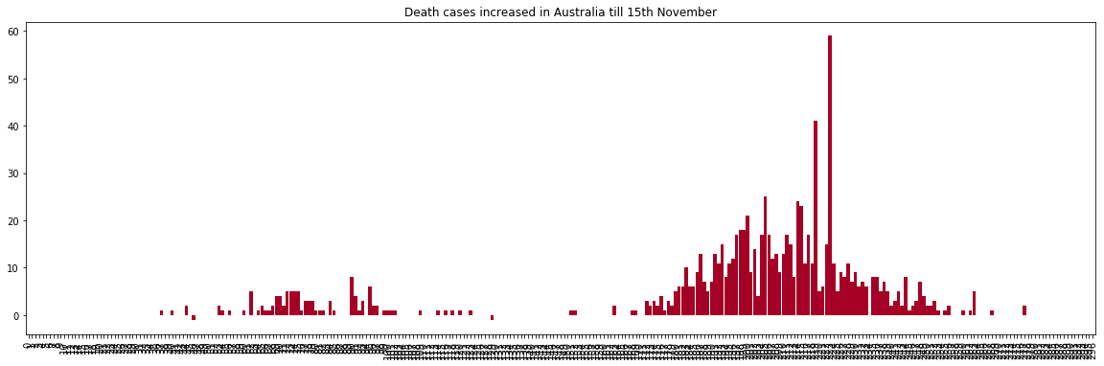

In recent times the death toll is increasing in the day to day basis in a huge quantity,which maycosttheGovernmentofAustraliainthispandemicsituation.Thedeathtollisincreasing day by day very much in Australia. Thehighestdeathtollisshowninthedayof11thAugust, 2020 where the death toll rises to 21, the highest in the whole pandemic situation

Australia had prevented the spreading of the virus but recently the country has shown the unconditional increase in the confirmed and death cases day to day.

## Chapter3:LOCKDOWN:TheSaviouror,not?

On March 24, Mr. Modi said: “I fold my hands to say — please stay where you are,” adding that “all leading experts say 21 days is the minimum we require to break the coronavirus transmission cycle. If we are not able to handle these 21 days, the country and your family will go back 21years and many families will be destroyed. I am saying this not as the Prime Minister but as yourfamilymember.”Thenightofhisaddress,Indiarecorded536cases—a six-fold jump in less than two weeks; there were 10 deaths.Governmentandhealthofficials feel that a complete lockdown and cessation of travel will keep those who are infected isolated and restrict infections to contained clusters. This would avoid community transmission when it becomes impossible to trace the source ofinfectionsandquarantining is of no use

The four months of lockdown delayed the peaking of cases, which significantly benefited us in the following ways Improved health infrastructure The lockdown gave the governments, both central and states, time to ramp up health infrastructure. Innovations in treatment Since the development of specific anti-viral medicine for COVID-19 will takepossiblyyears, the lockdown allowed doctors to come up with quick innovations in treatments by repurposing existing medicines for other diseases that have shown effectiveness against COVID-19. Lowering the mortality rate India has about1.75milliontotalcasesofCOVID-19 currently. Imagine this happening in April, instead of July, when there was a shortage of beds, ventilators, basic PPE kits and absence of any treatment.

Lockdown delayed the peaking of cases allowing breathing time for other innovations also like no-touch treatment, using technology (mobile, video telephony, robots etc) to provide critically needed but scarce healthcare workers safe environment to treat patients.

China’sLockdownPeriod:

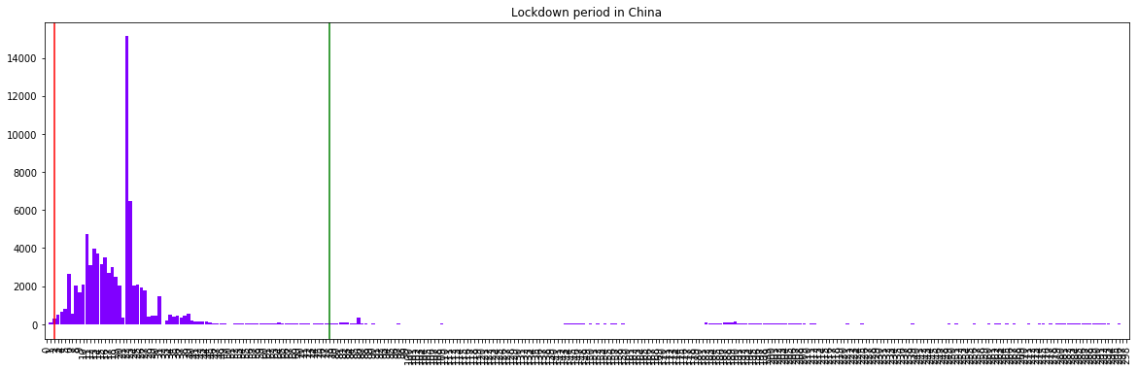

China's Lockdown : China imposed lockdown of all total 76 days and as a result the confirmed cases incrementation is nullified and turned out at a negligiblerate.Sodefinitely we can say that China imposed the lockdown in a correct manner as a result they had prevented the coronavirus spread[1]

Italy’sLockdownPeriod:

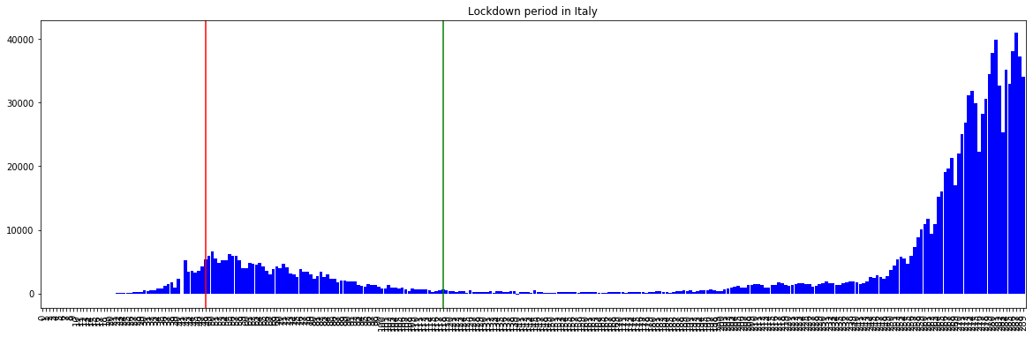

Italy's Lockdown : Due to rapid increase of corona virus spread in Italy, the government imposed lockdown on 9th March, 2020 and the lockdown elongated to 70 days as a result the increment in the confirmed cases were decreased from 6000 per day to 500 per day (approx.). Which signifies that Italy has prevented the spread out of the virus by imposing the lockdown, and we can clearly observe that the LOCKDOWN IS SUCCESSFUL FOR ITALY![12]

USA’sLockdownPeriod:

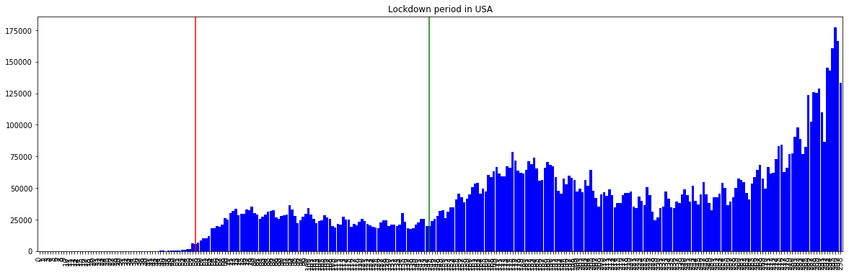

USA's Lockdown : United States of America imposed lockdown on 19th March, 2020 when they were at the initial stage and the cases were 10000. Afterthelockdownimplementation the cases were raised to 40000 daily and it was continued 87 days but the daily cases were notincreasedbeyond40000.AtthismomentDonaldTrumpdecidedtoopenUSAand re-open the economy as they faced a decrement of 4.5% GDP, and this will costthecountry hugely if the economy is not opened yet. As the lockdown revoked on 13th June, 2020, the cases are drastically increasing and creating anewrecordeveryday.Aswecanseethatafter the revocation of lockdown the condition became worser for USA. They have seen 80000 cases daily, and the tally is still increasing. Unfortunately, for USA the lockdown period is successful to some extent and to prevent the daily exponential increment but on the same side, it did not make the curve downward or evenflattened.ThelockdownincaseofUSAIS UNSUCCESSFUL![5]

GermanyLockdownPeriod:

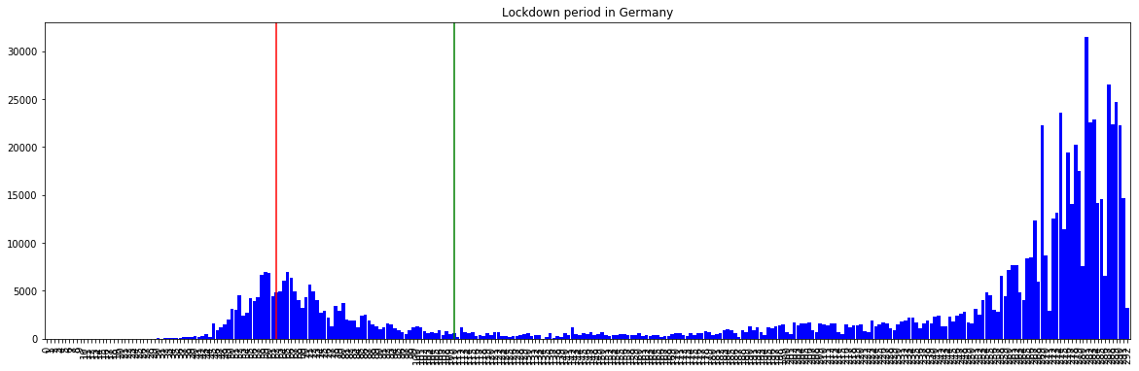

Germany Lockdown : The government of Germany imposed lockdown from 23rd March, 2020 when the country is facing high rise in the per day confirmed case rate. They faced merely7000casesperdayatthetimeoflockdown.Afterthelockdownwasimposed,the

daily new confirmed cases are slowly decreased within a month to 2000 cases per day. Whichshowsthatthelockdownactionis successful for the country and the health sectors. At this on10thMay,2020theyhaverevokedlockdowntore-openthecountryandeconomy. Still the cases are coming on a day to day basis but they are in a certain numbers around 1000. And also the death rate is also come down to 20 odd numbers. Which shows GERMANY SUCCESSFULLY IMPOSED LOCKDOWN AND PREVENTED THE BREAK THROUGH OF THE VIRUS[8]

Australia’sLockdownPeriod:

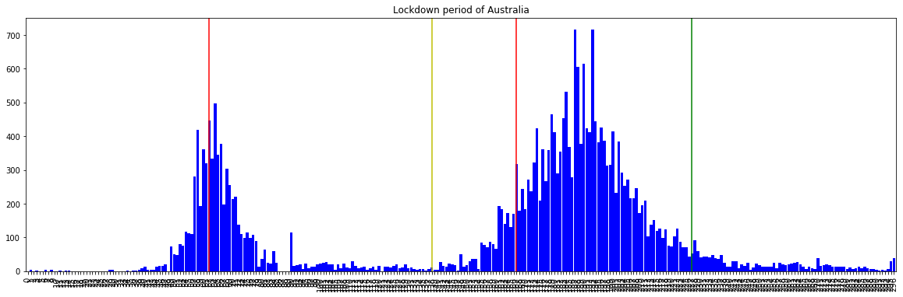

Australia Lockdown : The government imposed lockdown on23rdMarch,whenthecountry was facing the high rise in the daily confirmed cases.Afterimposingthelockdownproperly, the country stabilized the situation and the controlled the daily cases down to 100. At that moment the government declared that some areas will beeasedfromthelockdownandasa result they again saw the increment in the daily confirmed cases rapidly. At this the government imposed lockdown on 7th August, 2020 to prevent the cases. This time thecases were doubled up than the previous high rises. We can say that, AUSTRALIA SUCCESSFULLY CONTROLLED THE SPREAD OF THE VIRUS IN THE LOCKDOWN PERIOD, BUT WHENEVER THEY OPENED UP, IT BECAME WORSER FOR THEM.

Japan’sLockdownPeriod:

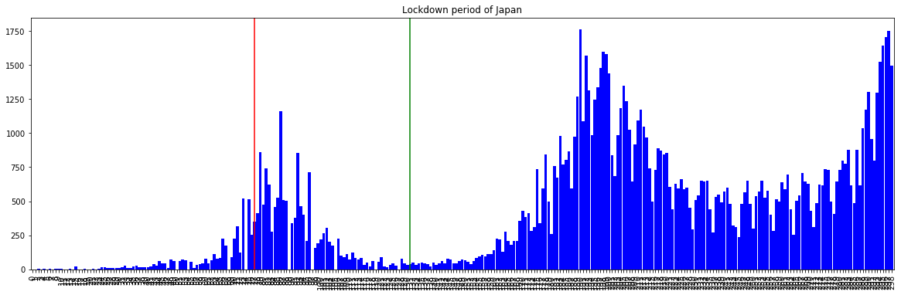

Japan Lockdown : On the situation of increasing confirmed cases the Japan government imposed lockdown on 7th April, and they successfully controlled the cases. But the worser days were yet to come for Japan. As the lockdown was revoked the cases were slowly increasing and in a few days the cases were increasing exponentially. The daily confirmed cases are raised to 1500. And the tally is still growing. But Japan was not imposing lockdown, rather they had started rigorous testing to prevent the virus. we can say that, JAPAN IS SUCCESSFUL IN THE EARLY LOCKDOWN PERIOD AND RIGHT NOW THEY HAVE INCREASED THE TESTING TO PREVENT THE VIRUS.

## Chapter4:India:Currentsituationandanalysis

The first case of coronavirus in India wasidentifiedon30January2020.By3February,the number of cases increased to 3. On 4 March, 22 newcaseswereidentified,ofwhich14were from a group of tourists who had arrived from Italy (The Week 2020). In March, Indiaalso reported its first coronavirus-related death. The numberofconfirmedcasesinIndiacrossed 1000 on 29 March, 30,000 on 28 April, and 180,000 on 30 May. The death toll crossed 50

on 1 April, 1000 on 28April,and5000on30May.Asof25thNovember2020,thenumbers of infected cases and deaths are 9,227,557 and 134,804, respectively (World meter 2020b).On 24 March 2020, the Government of India under Prime MinisterNarendraModi ordered a nationwide lockdown for 21 days, limiting movement of the entire 1.3 billion population of India as a preventive measure againsttheCOVID-19pandemicinIndia.Itwas ordered after a 14-hour voluntary public curfew on 22 March, followed by enforcement of a series of regulations in the country's COVID-19 affected regions.[11]

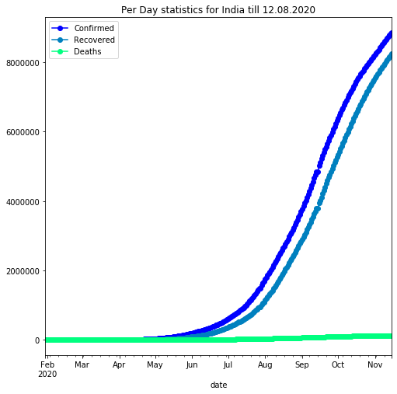Observing the cases in India. Confirmed cases are increasing in India each day. There is a need to get a flatter curve for confirmed cases which currently is in upswing with a steep increase since past few days.

India’sStatistics:

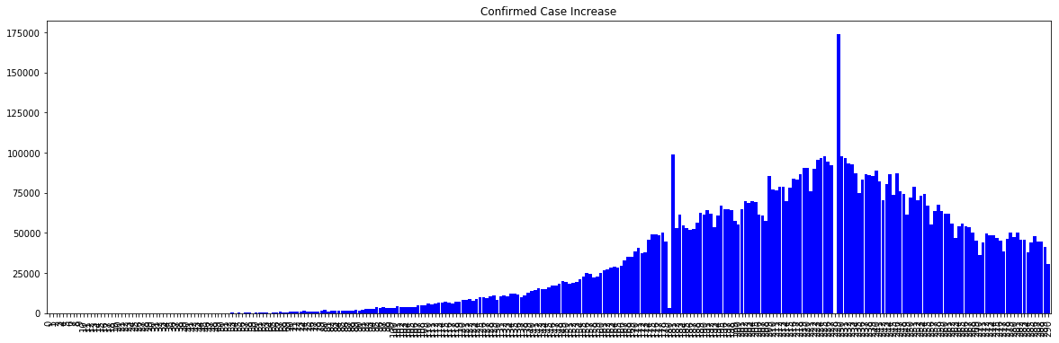

The day to dayconfirmedcasesareincreasingexponentiallyandeverydayIndiaiscreatinga new record on the per day confirmed cases

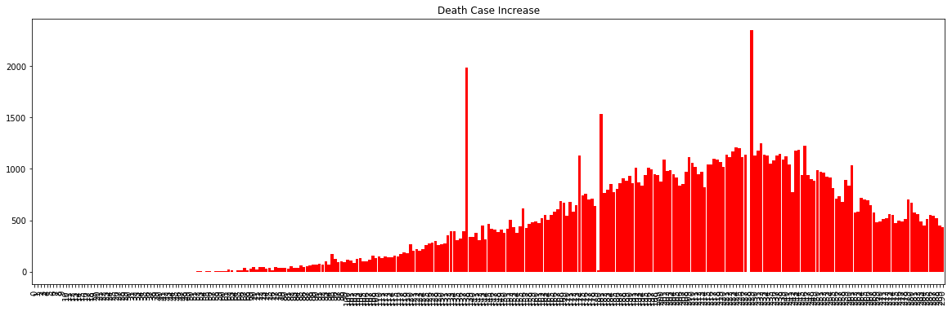

As the day to day confirmed cases are increasing exponentially the death cases are also increasing in the exponential manner with a rate of min 1000 people per day. The highest peak have obtained of 2000 people have died in a day. And the number is increasing daily

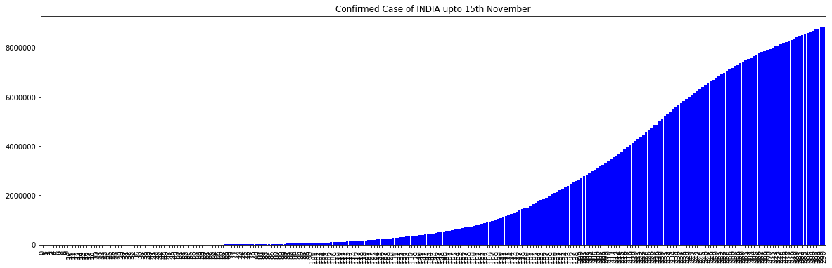

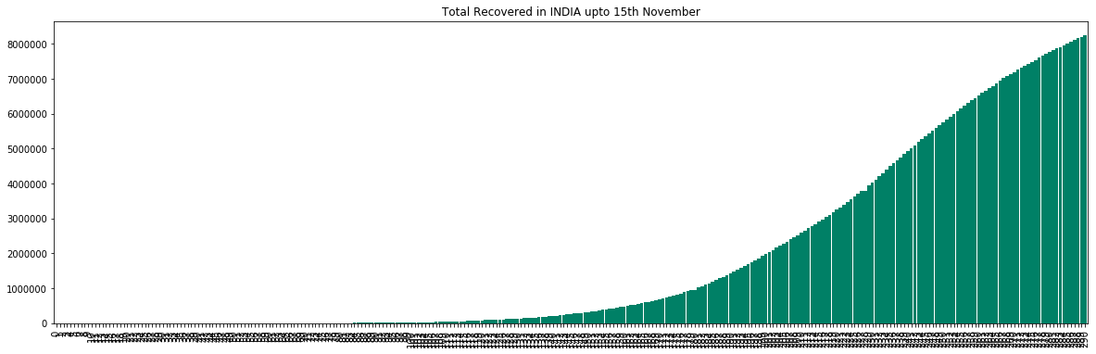

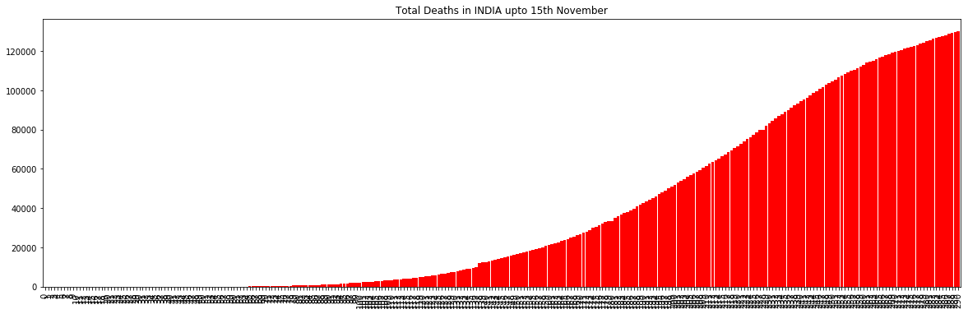

In the current situation of pandemic the confirmed cases are creating new record daily as well as the death cases.Thedeathtollrisesupto50000stillitisnotflatteninganymore.Not a single chance of flattening has seen in the curve rather the growth rate is exponentially. India is yet to have the worst situation like United States are having.

India’sLockdownProcedure:

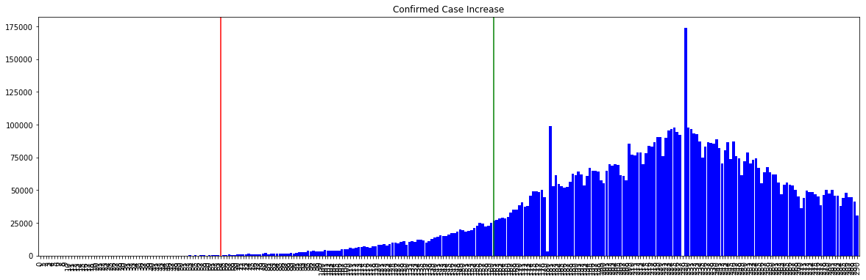

India Lockdown : After watching the world suffering from the virus, India has take precautionearlierandimposedlockdownon23rdmarch,2020.Afterthatthecaseswere

increasing in a daily basis and exponentially, and the toll reached to 40000 mark. At that time the government decided to revoke the lockdown. As a result the cases were raised to 2500000 (As of the data of 12th August, 2020). India is having the worst condition in the world. The cases areincreasing60000daily.Thereisnosignofflatteningthecurveratherit is exponentially increasingandthecurveisobtainingmoreandmoresteepslopedaybyday. INDIA, IN THE PERSPECTIVE OF LOCKDOWN WAS TOTALLY UNSUCCESSFUL, AND BECAME 3RD HIGHEST INFECTED COUNTRY IN THE WORLD.[11]

##### StatewiseAnalysisofIndia:

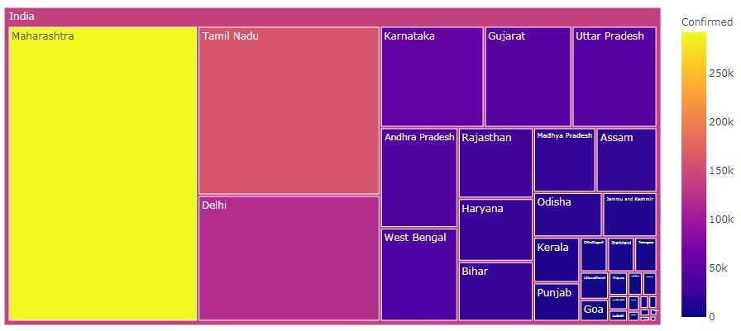The COVID-19 pandemic in Uttar Pradesh, India was first confirmed on 4 March 2020, withthefirstpositivecaseinGhaziabad.Asof31October2020,thestatehas4,81,863 confirmed cases, resulting in 7,025 deaths and 4,51,070 recoveries. The first case of the COVID-19 pandemic in the Indian state of Maharashtra was confirmed on 9 March 2020. Maharashtra is a hotspot thataccountsfornearlyone-thirdofthetotalcasesinIndiaaswell as about 40% of all deaths. As of 7 July, the state's case fatality rateisnearly4.3%,whichis lower than the global average but significantly higher than other Indian states with large numbers of cases. Mumbai is the worst-affected city in India, with about 100,000 cases Covid-19: Punjab govt to impose night curfew across the statefrom1Dec.WhereasinWest Bengal West Bengal registers 49 more Covid-19 deaths, 3,545 fresh cases. The first case of the COVID-19 pandemic in the Indian state of Assamwasreportedon31March2020.Asof 24 November 2020, the GovernmentofAssamhasconfirmedatotalof89,468positivecases of COVID-19 including 67,641 recoveries, three migrations and 234 deaths in the state.The state's as well as northeast's largest city, Guwahati, has been worst affected by coronavirus.

##### MaleandFemaleDistribution:

Older age and a high number of comorbidities were associated with higher severity and mortality in patients with both COVID-19 andSARS.Agewascomparablebetweenmenand women in all data sets. In the case series, however, men's cases tended to be more serious thanwomen's(P=0.035).In the public data set, the number of men who died from COVID-19 is 2.4 times that of women (70.3 vs. 29.7%, P = 0.016). While men and women have the same prevalence, men with COVID-19 are more at risk for worse outcomes and death, independent of age.[11]

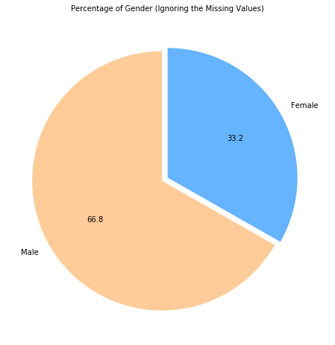

##### AgeGroupwisedistribution:

The Union health ministry’s analysis has shownthatnearlyhalfthepeoplewhohavediedof COVID-19 are aged below 60 years. Health secretary Rajesh Bhushan said that 53% of the people who died due to the viral infection are aged above 60. Also, 35% of the deaths were recorded in the age group of 45-60 years, 10% in the age group of 26-44 years and 1% eachin the age group of 18-25 years and below 17 years. Elderly people and those with comorbidities are at higher risk of mortality.The health ministry’s data once againconfirms that people who have underlying health conditions such ascardiovasculardisease,diabetes, kidney disease, high blood pressure or cancer are at greater risk of dying due to COVID-19 than patients these comorbidities.[11]

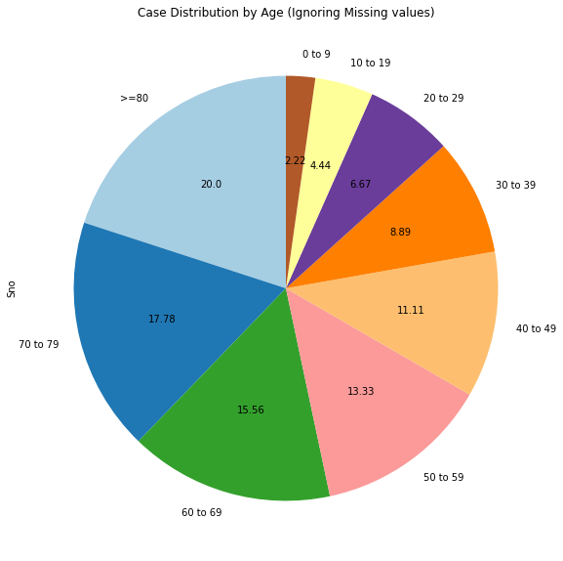

##### Recoveryratev/sDeathrateofvariousstates:

The number of people who have recovered from the coronavirusdisease(Covid-19)inIndia has crossed 2.7 million, pushing the country’s recovery rate to 76.61%. “Higher number of single-day recoveries is also reflected in the continuous increase in the national recovery rate, which isatpresent91.34percent,”theministryunderscored.India’sCOVID-19fatality rate stands at 1.49%, with 21 StatesandUTshavedeathspermillionlowerthanthenational average, the Ministry said.

80 per cent of the new recovered cases are observed to be concentrated in 10 States and Union Territories. Kerala is leading with more than 8,000 single day recoveriesfollowedby Karnataka with more than 7,000 recoveries. Delhi has the highest recovery rate.[11]

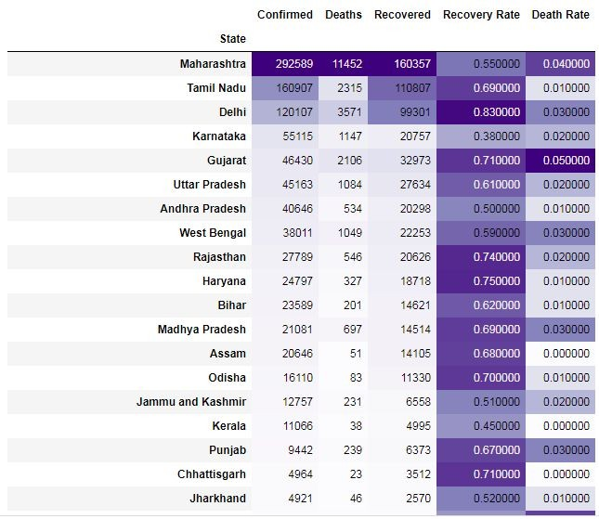

##### StatewiseTestingdone:

Report shows that the state which has done maximum tests is Tamil Nadu. Tamil Nadu has conducted total 18,79,499 tests. Maharashtra stands second with total 15,26,037 tests. The reportshowsthatTamilNaduandMaharashtrahastheworstcondition.Ontheotherhand, report shows Himachal Pradesh, Goa, Tripura has lower number of testing done. More number of testing should be done to ensure the actual number of active cases and as the number of beds in hospital is running out it should be increased.[11]

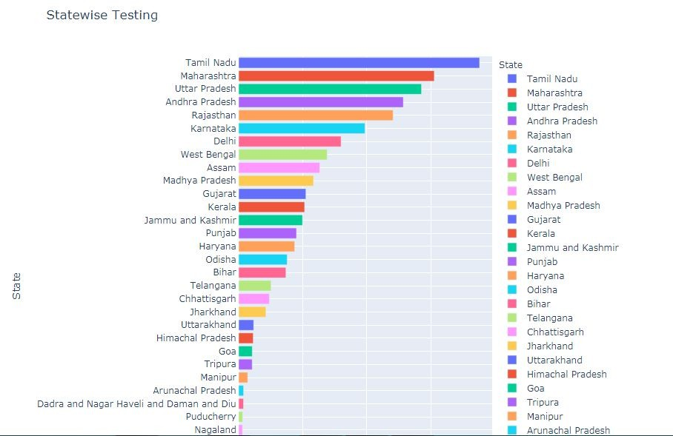

##### TotalTestedv/sPositivecases:

In Tamil Nadu total tests done is 18,70,499 and among them number of positive cases is 1,65,714. Likewise in Maharashtra number of total tests 15,26,037 and positive cases 30,55,41. In Uttar Pradesh total tests done is 14,26,303 and number of positive cases is 47,036. In Andhra Pradesh12,84,384peopleweretestedandamongthem44,609aretested positive. In Rajasthan 12,04,676 people were tested and among them 28,500 people tested positive. The positive test rate of Tamil Nadu, Maharashtra,UttarPradesh,AndhraPradesh and Rajasthan is respectively 0.0900, 0,2000, 0.03000, 0.03000 and 0.02000 [1]. These are the top five states for the testing done.

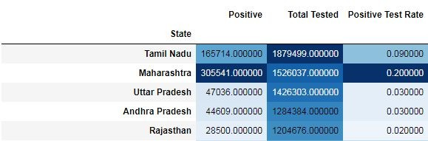

##### Statev/sTestingLabs:

India has been calibrating its testing strategy as per the changingparadigm,andtakinginto account the scope, need andcapacitytorapidlyscale-uptestsperformedeachdayacrossthe country.Overaperiodoffive months, the number of laboratories in the country rose from

14 in February to more than 1596 in August. The testing rate has been ramped up significantly over the last few months with the introduction of the rapid antigen detection test in addition to the molecular tests, which remain the mainstay of diagnosis.The central government expanded the network of governmentlaboratoriesdesignatedtotestsamplesof suspected coronavirus disease (Covid-19) cases to 1164 laboratories. Among 1164 government laboratories, 516 are approved to test for Real-Time PCR (RT PCR) tests, 609 for TrueNat screening tests, and 39 for CBNAAT testing. Also, additional 965 private laboratories were approvedtoconductCOVID-19tests.Among965privatelaboratories,634 are approved to test RT PCR tests, 242 to test for TrueNat tests and 89 to test for CBNAAT testing.[11]

Number of government and private testing centers for the coronavirus (COVID-19) across India as of November 22, 2020, by state

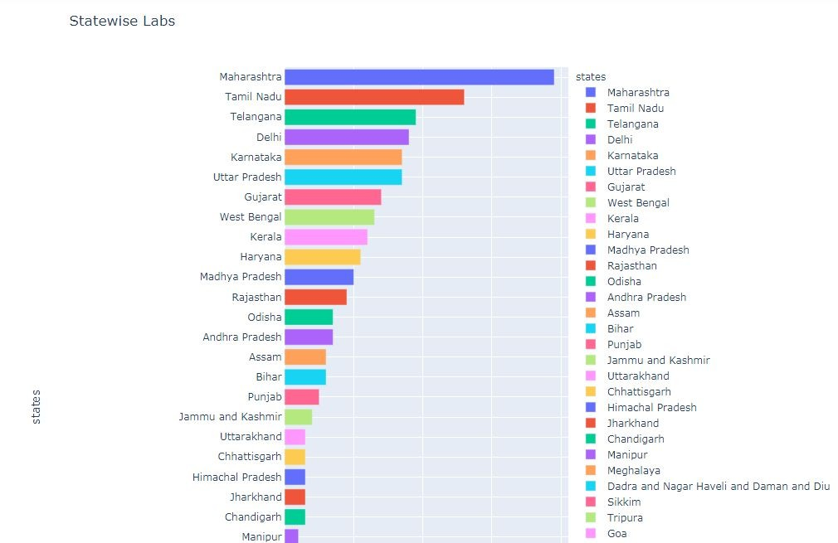

### Chapter 5 : Health Facility Condition of India

COVID-19 has led to a dramatic reduction in the numbers of patients seeking care. This is especially true of planned, non-urgent problems including procedures and surgeries. Many patients are scared to visit health facilities fearing COVID-19. While this has caused collateral damage, with the condition of some patients worsening or taking an unfortunate turn, there may indeed be those who have avoided interventions without any deleterious impact. In other words, they have been spared of procedures for debatable indications. For example, the large number of women who undergo an unnecessary hysterectomy has reduced. The incidence of Caesarean sections is reported to have gone down. Similarly, procedures such as coronary stents, knee replacements or cosmetic surgery which reflect supplier-induced demand have almost stopped. ‘Routine’ admissions for ‘observation’ or ‘insurance claims’ have got curtailed.

Strangely, even emergency medical cases have declined during the lockdown, with adecrease in the cases of heart attacksorstrokespresentingtohospitals.Whilesomeofthese may have been true emergencies involving those who suffered at home, perhaps the unpolluted air, decreased work stress, or home-cooked food has had a bigger impact on health than we assume. Or maybe we were over-diagnosing and over-treating certain emergencies. Investigating these important questions and critically analysing their answers may make future health care more beneficial to patients.

The cartelisation of health care has been naturally curbed during the pandemic. ‘Cut practice’, with doctors and hospitals prescribing tests, drugs, referrals and procedures in return for commissions, is entrenched in India. This leads to significant negative consequences, be it increased patient expenses, patientsnotreachingtherightdoctorornot getting the appropriate investigation, and also an erosion in the doctor-patient relationship and the image of the fraternity. It puts ethical doctors in a quandary, making them cynical about their profession. However, during the pandemic, the availability of doctors, beds and proximity are now the chief drivers for patient referrals, rather than the commission route. Most practices have had to take a forced ‘detox’ of sorts from this addiction.

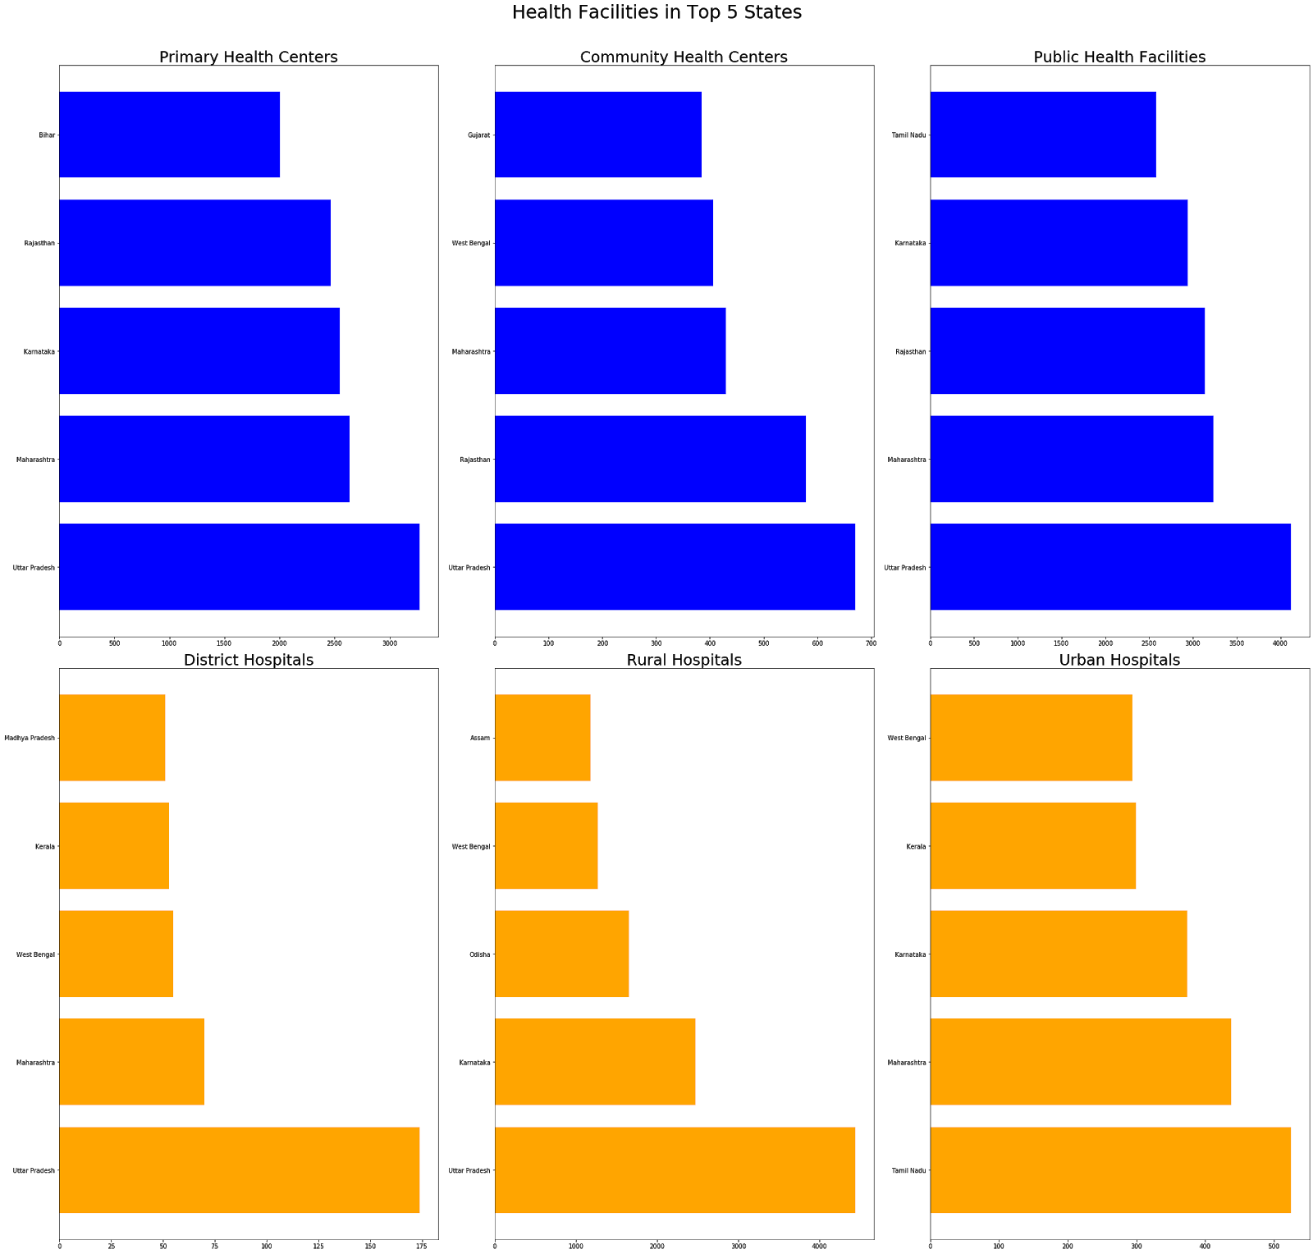

#1 Kerala: Niti Aayog ranked Kerala to be the healthiest state in India, in its recently published health index. The state recently underwent the scareofthespreadofNipahvirus, butit was contained. Kerala health minister KK Shailaja said the scare of the second attack of the virus in the state was over, earlier this month.

#2 Andhra Pradesh: The government think-tank ranked Andhra Pradesh second in itshealth index. In2017-2018,thestatehasseenanoutbreakofinfluenzaandin2018,theviral fever cases were on the rise. The state was also on high alert on the wake of theoutbreakof Nipah virus in Kerala.[11]

#3 Maharashtra: According to Niti Aayog,Maharashtraisthethird-healthieststateinIndia. AccordingtoareportbytheIndianExpress,17,000peopleinMaharashtradiedin2017

because of the persisting malnutrition crisis. In 2011, 77 babies died of hunger in Maharashtra, according to reports. This is, even though, the state is reportedly home to the most effective nutrition schemes.

#4Gujarat: Gujarat is ranked fourth in the index released by Niti Aayog. The state is home to many cities affected by air pollution. According to Lancet’s Global Burden of Diseases latest report, around 30,000[11] people died in the state because of air pollution. Thestate, currently, is undergoing the fear of measles-rubella (MR) and cases of kidney and brain disorders have been reported.

#5. Punjab: The state maintained the fifth spot as the Niti AayogreportsaidPunjabhasnot shown any improvement. Punjab has been witnessing a persistent drug problem which has cost more than 100 lives. According to a report by AIIMS released in 2015, the number of drug addicts was already as high as two lakh.

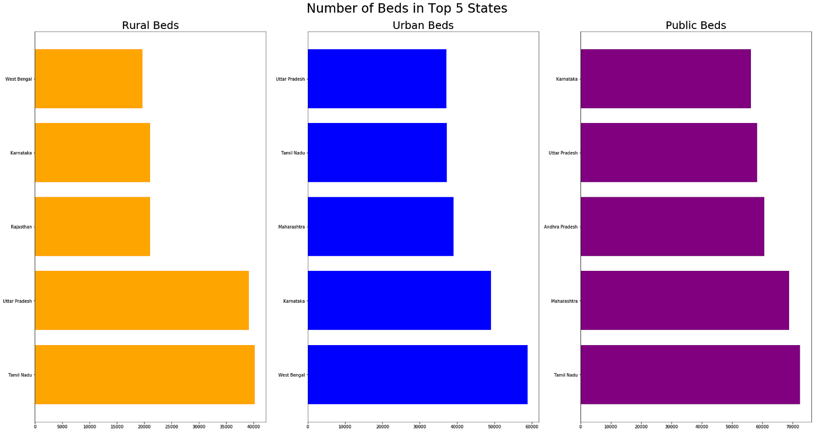

TotalbedsandNo.ofActivecases:

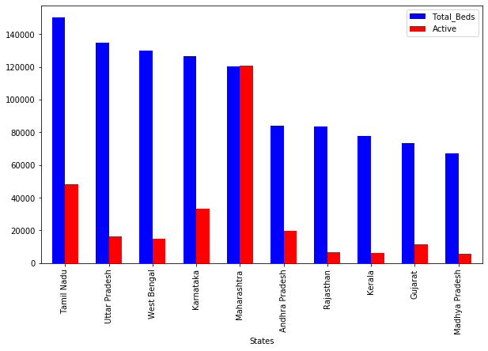

ThestateofMaharashtraisfacinglackingofbedsinthistimeperiod

As per logistic growth,Maharashtra was expected to reach the bed capacity in the firstweek of August,howevertherehasbeenrapidgrowthincasesandthebedcapacitywasreachedin last week ofJulyitself.Wearenowcheckingif50kbedsareaddedinMaharashtrawhenwill that capacity be reached.

## Chapter6:The Prediction

While it is impossible to estimate the eventual number of cases for the novel coronavirus, there was an exercise carried out earlier this year, aimed at projecting the numbers for Wuhan in China. In a recent article on Cell Discovery in Nature, a group of Chinesescientists attempted to estimate the eventual number of infections and deaths due to the disease (COVID-19) in Wuhan. An infectious disease dynamics model called SEIR (Susceptible-Exposed-Infectious-Resistant) was used to model and predict the number of COVID-19 cases. The SEIR model proved to be predictive for a variety of acute infectious diseases like Ebola and SARS.

The model classifies the population into four mutually exclusive groups: susceptible(atrisk of contracting the disease), exposed (infected but not yet infectious), infectious (capable of transmitting the disease), and removed (those who recover or die from the disease). A susceptible individual can become exposed only through contact with some infectious person. Susceptible individuals first enter the exposed stage, during which they may have a low level of infectivity; they become infectious thereafter. The infection rate represents the probability of transmission from an infectious person to a susceptible one. The incubation rate (the reciprocal of the average duration of incubation) is the rate at which latent individuals become infectious; and the removalrateisthereciprocaloftheaverageduration of infection. The basic reproduction number (BRN) is the expectednumberofcasesdirectly generated by onecase.ABRNgreaterthanoneindicatesthattheoutbreakisself-sustaining, while a BRN less than one indicates that the number of new cases decreases over time and eventually the outbreak will stop. Ideally, the BRN should bereducedinordertoslowdown an epidemic.

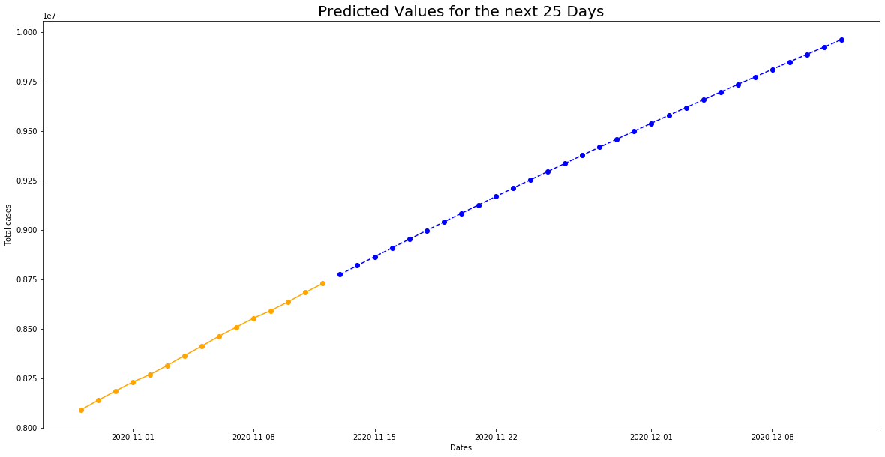

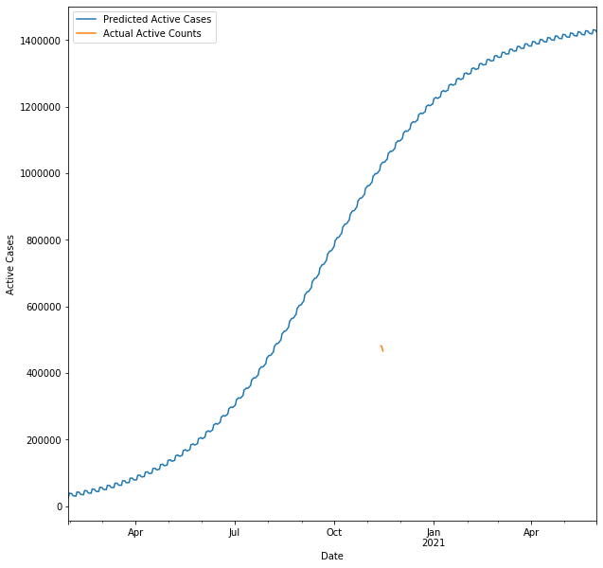

## ConclusionandDiscussion

ForthecountrieslikeIndia,USA,Brazil,theyaretheworstcandidatesofthispandemic,and the had suffered the most and still suffering. If we have to fought against the virus, we have test the samples in a huge number. Testing is the only without lockdown the country, as Japan is doing. Testing is the most essential thing, without which we cannot trace the curve and it will increase with a high slope.

According to the prediction, India will be seeing the flattened curve of daily confirmed cases in the month of March and April, 2021. And at that moment the country will have all total 50000000 confirmed cases, which will be the nightmare for the country. If the vaccine is availablethenitwillbeanotherthing,butiftheconfirmedcasesareincreasingattherateof 60kto70k,andeventuallyitwillincreaseto90kto100k,1/3ofthetotalpopulationofIndia will be effected

COVID-19 health crisis has exacerbated violence against doctors and healthcare workers. They have become unforeseen targets in the fight against the current pandemic. For a sustainable protection of the healthcare workers, the current Ordinance needs to be further extended and incorporated into existing laws in the form of a strict, permanent legislation that is strictly enforced. It would improve the safety of the very individuals who carry out theirdutiesfearlesslyforthebenefitofsickpatients,eitherduringahealthcrisissuchasthe current pandemic or during traditional times.[12]

## FutureScopeof Work

Based on this research workandprojectwecanusethisdatainanyplaces.Wecancreatean app in which if we put the datas of the hospitals and how many beds are there for further patients, it will be a great scope for us.

Based on the datasets and this analysis we can find out predictions from which wecanplan further proceedings.

Using this project any one can develop real time projectionsofthepredictionswiththehelp of the real time data and can create a better regression model to put predictions more accurately.

## References

1. ChineseData:<http://weekly.chinacdc.cn/news/TrackingtheEpidemic.htm>
2. HongKongDepartmentofHealth:<https://www.chp.gov.hk/en/features/102465.html>
3. MacauGovernment:<https://www.ssm.gov.mo/portal/>
4. TaiwanCDC:<https://sites.google.com/cdc.gov.tw/2019ncov/taiwan?authuser=0>
5. USCDC:<https://www.cdc.gov/coronavirus/2019-ncov/index.html>
6. GovernmentofCanada:

<https://www.canada.ca/en/public-health/services/diseases/coronavirus.html>

1. Australia Government Department of Health: <https://www.health.gov.au/news/coronavirus-update-at-a-glance>
2. European Centre for Disease Prevention and Control (ECDC): <https://www.ecdc.europa.eu/en/geographical-distribution-2019-ncov-cases>
3. MinistryofHealthSingapore(MOH):<https://www.moh.gov.sg/covid-19>
4. ItalyMinistryofHealth:<http://www.salute.gov.it/nuovocoronavirus>
5. MinistryofHealthandFamilyWelfare:GovernmentofIndia: <https://www.mohfw.gov.in/>
6. John Hopkins University Data Analysis : https://[www.bostonherald.com/2020/11/27/johns-hopkins-tips-to-make-the-air-in-your](http://www.bostonherald.com/2020/11/27/johns-hopkins-tips-to-make-the-air-in-your)

-home-safer-from-coronavirus/